**CHARTER SCHOOL PERFORMANCE CERTIFICATE**

SECTION ONE: INTRODUCTION AND RECITALS

This Charter School Performance Certificate (“Certificate”) is executed on this 9 day of September 2024, by and between the Middleton School District Board of Directors (the “Authorizer”), and Promise Academy, Inc., (“Promise Academy”) an independent public school organized as an Idaho nonprofit corporation (collectively the “Parties”) and established under the Public Charter Schools Law, Idaho Code Section 33-5201 *et seq*, as amended (the “Charter Schools Law.”)

WHEREAS, on July 10, 2024, Promise Academy’s Board of Directors (the “Charter Board” and “Charter Holder”) submitted an updated Charter Petition (the “Charter”) to the Authorizer to establish and operate Promise Academy; and

WHEREAS, on September 9, 2024, the Authorizer approved the updated Promise Academy Charter;

NOW THEREFORE in consideration of the foregoing recitals and mutual understandings, Authorizer and Promise Academy agree and Certificate as follows:

SECTION TWO: AUTHORIZATION OF CHARTER SCHOOL

**A. Establishment of School.** Pursuant to the Charter Schools Law, the Authorizer hereby approves the establishment of Promise Academy pursuant to the terms and conditions set forth in this Certificate. Promise Academy will be bound by and operated in a manner consistent with the terms of this Certificate so long as such terms are in accordance with state, federal and local law. Promise Academy’s approved Charter is attached to this Certificate as Appendix C.

**B. Certificate Term.** The Certificate term is five years, effective as of July 1, 2023, and shall continue through June 30, 2028, unless earlier terminated as provided herein and in accordance with the Charter School Act. This Certificate may be renewed for an additional period upon application by Promise Academy for renewal in accordance with the Charter Schools Act and the Authorizer’s approval of Promise Academy’s application for renewal.

**C. Pre-Opening Requirements.** Pursuant to Idaho Code Section 33-5206(8), the Authorizer may establish reasonable pre-opening requirements or conditions to monitor the start-up progress of a newly approved public charter school. The pre-opening requirements established by the Authorizer for Promise Academy are attached and incorporated herein as Appendix A. Promise Academy shall not commence instruction until the Authorizer has acknowledged in writing Promise Academy’s completion of all pre-opening requirements.

SECTION 3: CORPORATE STATUS AND GOVERNANCE

**A. Corporate Status.** Promise Academy is incorporated as an Idaho nonprofit corporation. Promise Academy shall continue to provide for governance of Promise Academy as an Idaho nonprofit corporation and Promise Academy shall operate as a public charter school in accordance with its Articles of Incorporation (“Articles”) and Bylaws.

**B. Governing Board.** Promise Academy shall be governed by a board (the “Charter Board”) in a manner that is consistent with the terms of this Certificate so long as such provisions are in accordance with state, federal, and local law. The composition of the Charter Board shall, at all times, be determined by and consistent with the Articles and Bylaws and all applicable law and policy. The Charter Board shall have final authority and responsibility for the academic, financial, and organizational performance of Promise Academy. The Charter Board shall also have authority for and be responsible for policy and operational decisions of Promise Academy, although nothing herein shall prevent the Charter Board from delegating decision-making authority for policy and operational decisions to officers, employees, and agents of Promise Academy, as well as third party management providers.

**C. Articles of Incorporation and Bylaws.** The Articles and Bylaws of the Charter Holder shall provide for governance of Promise Academy as an Idaho nonprofit corporation and operation as public charter school and shall be consistent with applicable law and this Certificate. Promise Academy shall notify the Authorizer of any changes to its bylaws or articles of incorporation within five (5) business days of ratification or adoption by the Charter Board.

**D. Charter Board Composition.** The composition of the Charter Board shall be determined by and consistent with the Articles and Bylaws and all applicable law and policy. The Charter Board shall notify the Authorizer of any changes to its composition and provide an amended School Leadership Roster within five (5) business days of their taking effect.

SECTION 4: EDUCATIONAL PROGRAM

**A. School Mission.** The mission of Promise Academy is as follows: “United with the Residential Center team we nurture academic growth for our youth on their journey to hope, healing and resilience.” Idaho Youth Ranch Mission Statement: “We unite for Idaho's youth by providing accessible programs and services that nurture hope, healing, and resilience.”

**B. School Core Values. The Core Values of Promise Academy are as follows:** (1) Relationships are the foundation; (2) Commitment to our mission unites us; (3) Growth is always possible; (4) Compassion is our lens; (5) Transparency makes us stronger; and (6) Joy sustains us.

**C. School Key Design Elements.** Promise Academy shall implement and maintain the following essential design elements of its educational program:

The Key Design Elements of Promise Academy are detailed in the approved Charter and are summarized herein, as follows:

(1) *Blended Learning*: Promise Academy will provide a combination of direct small group instruction in an experiential model, guided independent study, and supervised online coursework.

(2) *Mastery Based Individualized Education*: Each student will have the opportunity to learn content at a pace that is appropriate to their academic and behavioral needs.

(3) *Life Skills to Carry Forward*: Promise Academy will help students build the mindsets, skills, and attitudes that enable them to succeed in school and in life.

(4) *Post-Enrollment Continuity and Support*: Each student’s ILP, SICA data, performance level data, credit completion or progress toward credit completion and general class level performance will be communicated with their home school.

(5) *Year-Round Instruction - Daily Schedule to Accommodate Treatment*. Promise Academy will operate on a year-round basis with a calendar that corresponds to the scheduling requirements of the therapeutic programming of the residential facility.

**D. Grades Served and Maximum Enrollment Capacity.** Promise Academy is authorized to serve a maximum of 70 students ages 8 to 17.

**E. Standardized Testing.** Unless otherwise exempted by State or Federal law or policy,students of Promise Academy shall be tested with the same standardized tests as other Idaho public school students.

**F. Accreditation.** Promise Academy shall be accredited as provided by rule of the Idaho State Board of Education.

SECTION 4: AUTHORIZER ROLE AND RESPONSIBILITIES

**A. Oversight Allowing Autonomy.** The Authorizer shall comply with the provisions of Charter School Law and the terms of this Certificate in a manner that does not unduly inhibit the autonomy of Promise Academy. The Authorizer’s role is to evaluate Promise Academy’s outcomes according to this Certificate rather than to establish the process by which Promise Academy achieves the outcomes sought.

**B. Promise Academy’s Performance Framework.** Promise Academy’s Performance Framework is attached and incorporated into this Certificate as Appendix B. The Authorizer shall use the Performance Framework to evaluate Promise Academy’s Academic, Financial, and Operational performance. The Performance Framework supersedes and replaces all assessment measures, educational goals and objectives, financial operations metrics, and operational performance metrics set forth in the Charter and not explicitly incorporated into the Performance Framework. Following charter authorization, the Authorizer and Promise Academy will negotiate appropriate, rigorous Performance Framework measures; ultimately, following negotiations, the Performance Framework measures are determined by the Authorizer and shall be binding on Promise Academy.

**C. Performance Reporting by School.** Promise Academy shall prepare and submit reports regarding its governance, operations, and/or finances to the Authorizer to facilitate the completion of the Authorizer’s Annual Report, and upon the request of the Authorizer.

**D. Authorizer Annual Performance Monitoring**. At least annually, the Authorizer shall monitor and report on Promise Academy’s progress in relation to the measures set out in Promise Academy’s Performance Certificate. With respect to Promise Academy’s Academic, Operational and Financial Performance, based on review of the measures in the Performance Certificate, the Authorizer shall designate an accountability standard for each area (Academic, Operational, and Financial) of Meets Standard, Approaches Standard, or Does Not Meet Standard. Each year, the Authorizer shall provide Promise Academy a draft Annual Report no less than thirty (30) days prior to the meeting at which the Annual Report is to be considered by the Authorizer. Promise Academy will be afforded the opportunity to provide a written response to the draft Annual Report no later than fourteen (14) day prior to the meeting. The Authorizer will consider and incorporate Promise Academy’s comments at the Authorizer’s discretion. If no written response is provided, the School shall have the opportunity to respond orally to the draft Annual Report at the meeting. Within ten (10) days of receipt, Promise Academy shall post the final Annual Report on its website.

**E. School Performance – Charter Renewal.** In accordance with Idaho Code 39-5809B, Promise Academy’s performance in relation to the measures set forth in the Academic, Operational and Financial sections of the Performance Framework shall provide the basis upon which the Authorizer will decide whether to renew Promise Academy’s Charter at the end of the Certificate term. In accordance with the Charter School Law, the Authorizer shall renew Promise Academy’s charter if, as determined in the Authorizer’s Annual Report issued by November 15th proceeding the Authorizer’s renewal decision, Promise Academy meets all terms of this Certificate.

**F. School Performance – Charter Renewal with Conditions.** In accordance with Idaho code 39-5809B, the Authorizer may grant renewal with specific, written conditions for necessary improvements related to Promise Academies academic, financial, and/or operational performance measures. Any such specific, written conditions shall state the date by which the conditions must be met.

**F. Authorizer’s Right to Review.** Promise Academy will be subject to review of its academics, operations, and finances by the Authorizer, including related policies, documents, and records, when the Authorizer deems such review necessary to evaluate Promise Academy’s compliance with legal requirements and this Certificate. The Authorizer shall conduct its reviews in a manner that does not unduly inhibit the autonomy granted to Promise Academy.

**G. Site Visits.** In addition to the above procedures, the Charter School shall grant reasonable access to, and cooperate with, the Authorizer, its officers, employees, and other agents, including allowing site visits by the Authorizer, its officers, employees, or other agents, for the purpose of allowing the Authorizer to fully evaluate the operations and performance of the School. The Authorizer may conduct a site visit with advanced notice at any time if the Authorizer has reasonable concern regarding the operations and performance of the School.

SECTION 5: SCHOOL OPERATIONS

**A. In General.** Promise Academy and the Charter Board shall operate in accordance with all federal and state laws, local ordinances and regulations, and applicable Idaho Board of Education and/or Authorizer policies applicable to charter schools.

**B. Maximum Enrollment.** The maximum number of students who may be enrolled in Promise Academy shall be 70.

**C. Enrollment Policy – Non-Discrimination.** Promise Academy shall make student recruitment, admissions, enrollment, and retention decisions in a nondiscriminatory manner and without regard to race, color, creed, national origin, sex, gender identification, LGBTQ status, marital status, religion, ancestry, disability or need for special education services. In no event may Promise Academy limit admission based on race, ethnicity, national origin, disability, gender, income level, athletic ability, or proficiency in the English language. If there are more applications to enroll in the charter school than there are spaces available, Promise Academy shall select students to attend using a random selection process that shall be publicly noticed and open to the public.

**D. School Location.** 28371 El Paso Rd, Caldwell, ID 83607. Promise Academy is located at the address provided. Promise Academy shall provide reasonable notification to the Authorizer of any change in the location of its facilities.

**E. Attendance Area.** Promise Academy’s primary attendance areas are as follows: Promise Academy will serve students from families that reside at the Psychiatric Residential Treatment Facility owned and operated by the Idaho Youth Ranch on the Hands of Promise Campus at the School Location address provided above in provision D. Accordingly, Promise Academy’s primary attendance zone for purposes of admissions is defined as the Hands of Promise Campus, 28371 El Paso Rd, Caldwell, ID 83607. The secondary attendance zone consists of the Middleton School District, and the tertiary attendance zone consists of the remaining area of Canyon County, Idaho.

**F. Staff.** Instructional staff shall be certificated in compliance with Idaho law. All full-time staff members of Promise Academy will be covered by the public employee retirement system, federal social security, unemployment insurance, worker’s compensation insurance, and health insurance.

**G. Alignment with All Applicable Law.** Promise Academy shall comply with all applicable federal and state laws, rules, and regulations. In the event any such laws, rules, or regulations are amended, Promise Academy shall be bound by any such amendment upon the effective date of said amendment.

SECTION 6: SCHOOL FINANCE

**A. General.** Promise Academy shall comply with all applicable financial and budget statutes, rules, regulations, and financial reporting requirements, as well as the requirements contained in Promise Academy’s Performance Framework incorporated into this Certificate as Appendix B.

**B. Financial Controls.** At all times, Promise Academy shall maintain appropriate governance and managerial procedures and financial controls which shall include, but not be limited to: (1) commonly accepted accounting practices and the capacity to implement them (2) a checking account; (3) adequate payroll procedures; (4) procedures for the creation and review of monthly and quarterly financial reports, which procedures shall specifically identify the individual who will be responsible for preparing such financial reports in the following fiscal year; (5) internal control procedures for cash receipts, cash disbursements and purchases; and (6) maintenance of asset registers and financial procedures for grants in accordance with applicable state and federal law.

**C. Financial Audit.** Promise Academy shall submit audited financial statements from an independent auditor to the Authorizer no later than November 1 of each year beginning in November of 2024.

**D. Annual Budgets.** Promise Academy’s Board shall adopt a budget for each fiscal year, prior to the beginning of the fiscal year. The budget shall be in the Idaho Financial Accounting Reporting Management Systems (IFARMS) format and any other format as may be reasonably requested by the Authorizer.

SECTION 7: RELINQUISHMENT, NON-RENEWAL AND REVOCATION

**A. Relinquishment by Promise Academy.** Should Promise Academy choose to relinquish its Charter before the expiration of the Certificate, it may do so upon written notice to the Authorizer. In such a case, Promise Academy shall work with the Authorizer to ensure a smooth and orderly closure and transition for students and parents in compliance with the then-current Closure Protocols established by Idaho’s state-wide charter school authorizer, the Idaho Public Charter School Commission (IPCSC).

**B. Nonrenewal by Authorizer.** In accordance with Idaho Code Section 33-5209B,and pursuant to the Authorizer’s written Non-Renewal and Revocation Procedures, the Authorizer may non-renew Promise Academy’s Charter at the expiration of the Certificate if Promise Academy failed to meet or exceed the standard one (1) or more of the three (3) measured Performance Framework areas (Academic, Operations, Finance), as determined in the Authorizer Annual Report proceeding the renewal decision.

**C. Revocation.** Revocation is the termination of a school’s charter during, not at the end of, the term of the school’s current Performance Certificate. The Authorizer may revoke Promise Academy’s charter School’s only for the reasons, and only using the process, enumerated in Idaho Code 33-5209C and pursuant to the Authorizer’s written Non-Renewal and Revocation Procedures. In such an event, the Authorizer shall consider whether to revoke Promise Academy’s charter at its next regularly scheduled meeting. The decision shall be made at that time. Promise Academy may appeal a decision to revoke directly to the state board of education.

**D. Dissolution and Closure.** Upon relinquishment of the Charter for any reason by the Charter Board, or upon nonrenewal or revocation by the Authorizer, the Charter Board shall work with the Authorizer to ensure a smooth and orderly closure and transition for students and parents, in compliance with the Idaho Public Charter School Commission’s then-current Closure Protocols. The Charter Board will supervise and have authority to conduct the winding up of the business and other affairs of Promise Academy in accordance with the IPCSC Closure Protocols. The Authorizer will not be responsible for and will not assume any liability incurred by Promise Academy.

**E. Disposition of School’s Assets upon Termination or Dissolution.** Upon termination of the Charter for any reason, any assets owned by Promise Academy shall be distributed in accordance with the Charter Schools Law.

SECTION 8: MISCELLANEOUS

**A. No Employee or Agency Relationship.** None of the provisions of this Certificate will be construed to create a relationship of agency, representation, joint venture, ownership, or employment between the Authorizer and Promise Academy.

**B. Additional Services.** Except as may be expressly provided in this Certificate, or as set forth in any subsequent written agreement between Promise Academy and the Authorizer, or as may be required by law, neither Promise Academy nor the Authorizer shall be entitled to the use of or access to the services, supplies, or facilities of the other.

**C. No Third-Party Beneficiary.** This Certificate shall not create any rights in any third parties, nor shall any third party be entitled to enforce any rights or obligations that may be possessed by either party to this Certificate.

**D. Amendment.** This Certificate may be amended by mutual agreement between the Charter Board and the Authorizer, in accordance with Idaho Code 33-5205B. All amendments must be in writing and signed by the Charter Board Chair and the Authorizer.

IN WITNESS WHEREOF, the Authorizer and Promise Academy have executed this Performance Certificate to be effective July 1, 2023.

_____________________________________________________

Chair Charter School Board Date

_____________________________________________________

Chair Middleton School Board Date

**Appendix A: Pre-Opening Requirements**

**Appendix B: Performance Framework**

**Appendix C: Charter**

**Appendix D: Conditions of Authorization/Renewal** (NA - No conditions of authorization or renewal are applicable.)

**Appendix A: Pre-Opening Requirements**

Prior to serving students, Promise Academy must receive the Authorizer’s written confirmation that all pre-opening requirements are met:

|  |  |  |
| --- | --- | --- |
| Requirement | Date Submitted by Promise Academy | Date Approved by Authorizer |
| Performance Certificate Executed |  |  |
| Bylaws Executed |  |  |
| Articles of Incorporation Executed |  |  |
| Conflict of Interest and/or Code of Ethics Statement Executed |  |  |
| Facility Plan in Place / Executed |  |  |
| Annual Board Approved Budget |  |  |
| 501c3 Approval Letter |  |  |
| Org Chart Provided to Authorizer |  |  |
| Board Member (Chair) and School Leader Contact Information to Authorizer |  |  |
| Emergency Incident Team Communication Plan provided to Authorizer |  |  |

**Appendix B: Performance Framework**

**PERFORMANCE FRAMEWORK**

**ACADEMIC MEASURES**

Promise Academy’s primary attendance zone serves a unique population of students in the State of Idaho. These students reside at the Idaho Youth Ranch Residential Center for Healing & Resilience. All students have clinical diagnoses of Serious Emotional Disturbance, many with other complicating factors. Many students at Promise Academy have existing Individual Education Plans or 504 plans. Students at Promise Academy may start at any time of the calendar year and may stay for as little as 30 days or for as long as 9 months. Students will often experience a 2–3-week period of transition to become familiar with the facility, the school, and experiencing intensive therapeutic treatment while residing at IYR’s residential treatment center. Most students will attend Promise Academy for longer than 30 days. Accordingly, the Academic Measures correlate to the amount of time a student attends Promise Academy: 30 days; 60 days; 3 months; 6 months; and 9 months

**Academic Progress**

1. Daily progress through curriculum standards
2. Weekly grades or grade equivalents determined through unit assessments
3. Specific daily progress monitoring of student individual growth in Math
4. Specific daily progress monitoring of student individual growth in Language Arts

**Classroom Behavior**

1. Daily incidents of disruptive behavior or refusal to work
   1. Progress monitoring of positive behaviors

**Academic Progress Measures 1-4:** Academic growth, both at grade level and at individual performance level, is the definition of progress in this area. Student academic growth is critical to success at Promise Academy and to the transition to the home district. All students can learn and deserve to learn.

**1. Daily progress through curriculum standards**

**First 30 Days**

Meets Standard: 60% of the student population attending Promise Academy for this timeframe completed at least 70% of assigned daily work in academic classes with passing marks.

Does Not Meet Standard: Less than 60% of the student population attending Promise Academy for this timeframe completed at least 70% of assigned daily work in academic classes with passing marks.

**30 Through 60 Days (2 Months)**

.

Meets Standard: 70% of the student population attending Promise Academy for this timeframe completed at least 70% of assigned daily work in academic classes with passing marks.

Does Not Meet Standard: Less than 70% of the student population attending Promise Academy for this timeframe completed at least 70% of assigned daily work in academic classes with passing marks.

**60 Through 90 Days (3 Months)**

Meets Standard: 80% of the student population attending Promise Academy for this timeframe completed at least 70% of assigned daily work in academic classes with passing marks.

Does Not Meet Standard: Less than 80% of the student population attending Promise Academy for this timeframe completed at least 70% of assigned daily work in academic classes with passing marks.

**90 Through 180 Days (6 Months)**

Meets Standard: 85% of the student population attending Promise Academy for this timeframe completed at least 70% of assigned daily work in academic classes with passing marks.

Does Not Meet Standard: Less than 85% of the student population attending Promise Academy for this timeframe completed at least 70% of assigned daily work in academic classes with passing marks.

**180 Through 270 Days (9 Months)**

Meets Standard: 90% of the student population attending Promise Academy for this timeframe completed at least 70% of assigned daily work in academic classes with passing marks.

Does Not Meet Standard: Less than 90% of the student population attending Promise Academy for this timeframe completed at least 70% of assigned daily work in academic classes with passing marks.

Data Sources: Classroom teacher electronic gradebooks. This data will be accessible through a student information system and learning management system to be determined.

**2. Weekly grades or grade equivalents determined through unit assessments**

**First 30 Days**

Meets Standard: 75% of the student population attending Promise Academy for this timeframe achieved at least 60% on a 100 point scale on academic unit assessments by the end of the measured period.

Does Not Meet Standard: Less than 75% of the student population attending Promise Academy for this timeframe achieved at least 60% on a 100 point scale on academic unit assessments by the end of the measured period.

**30 Through 60 Days (2 Months)**

Meets Standard: 75% of the student population attending Promise Academy for this timeframe achieved at least 70% on a 100 point scale on academic unit assessments by the end of the measured period.

Does Not Meet Standard: Less than 75% of the student population attending Promise Academy for this timeframe achieved at least 70% on a 100 point scale on academic unit assessments by the end of the measured period.

**60 Through 90 Days (3 Months)**

Meets Standard: 75% of the student population attending Promise Academy for this timeframe achieved at least 75% on a 100 point scale on academic unit assessments by the end of the measured period.

Does Not Meet Standard: Less than 75% of the student population attending Promise Academy for this timeframe achieved at least 75% on a 100 point scale on academic unit assessments by the end of the measured period.

**90 Through 180 Days (6 Months)**

Meets Standard: 75% of the student population attending Promise Academy for this timeframe achieved at least 80% on a 100 point scale on academic unit assessments by the end of the measured period.

Does Not Meet Standard: Less than 75% of the student population attending Promise Academy for this timeframe achieved at least 80% on a 100 point scale on academic unit assessments by the end of the measured period.

**180 Through 270 Days or More (9 Months)**

Meets Standard: 75% of the student population attending Promise Academy for this timeframe achieved at least 85% on a 100 point scale on academic unit assessments by the end of the measured period.

Does Not Meet Standard: Less than 75% of the student population attending Promise Academy for this timeframe achieved at least 85% on a 100 point scale on academic unit assessments by the end of the measured period.

Data Source: Assessment scores as collected and reported by classroom teachers in a student information system and learning management system to be determined.

**3. Specific daily progress monitoring of student individual growth in Math.**

**First 30 Days**

Meets Standard: 75% of the student population attending Promise Academy for this timeframe achieved at least .20 of a grade level of growth in Math.

Does Not Meet Standard: Less than 75% of the student population attending Promise Academy for this timeframe achieved at least .20 of a grade level of growth in Math.

**30 Through 60 Days (2 Months)**

Meets Standard: 75% of the student population attending Promise Academy for this timeframe achieved at least .25 of a grade level of growth in Math.

Does Not Meet Standard: Less than 75% of the student population attending Promise Academy for this timeframe achieved at least .25 of a grade level of growth in Math.

**60 Through 90 Days (3 Months)**

Meets Standard: 75% of the student population attending Promise Academy for this timeframe achieved at least .5 of a grade level of growth in Math.

Does Not Meet Standard: Less than 75% of the student population attending Promise Academy for this timeframe achieved at least .5 of a grade level of growth in Math.

**90 Through 180 Days (6 Months)**

Meets Standard: 75% of the student population attending Promise Academy for this timeframe achieved at least .66 of a grade level of growth in Math.

Does Not Meet Standard: Less than 75% of the student population attending Promise Academy for this timeframe achieved at least .66 of a grade level of growth in Math.

**180 Through 270 Days (9 Months)**

Meets Standard: 75% of the student population attending Promise Academy for this timeframe achieved at least 1 of a grade level of growth in Math.

Does Not Meet Standard: Less than 75% of the student population attending Promise Academy for this timeframe achieved at least 1 of a grade level of growth in Math.

Data Source:Daily student progress monitoring data collected from a leveled Math program to be determined (such as Mobymax).

**4. Specific daily progress monitoring of student individual growth in Language Arts.**

**First 30 Days**

Meets Standard: 75% of the student population attending Promise Academy for this timeframe achieved at least .20 of a grade level of growth in Language Arts.

Does Not Meet Standard: Less than 75% of the student population attending Promise Academy for this timeframe achieved at least .20 of a grade level of growth in Language Arts.

**30 Through 60 Days (2 Months)**

Meets Standard: 75% of the student population attending Promise Academy for this timeframe achieved at least .25 of a grade level of growth in Language Arts.

Does Not Meet Standard: Less than 75% of the student population attending Promise Academy for this timeframe achieved at least .25 of a grade level of growth in Language Arts.

**60 Through 90 Days (3 Months)**

Meets Standard: 75% of the student population attending Promise Academy for this timeframe achieved at least .5 of a grade level of growth in Language Arts.

Does Not Meet Standard: Less than 75% of the student population attending Promise Academy for this timeframe achieved at least .5 of a grade level of growth in Language Arts.

**90 Through 180 Days (6 Months)**

Meets Standard: 75% of the student population attending Promise Academy for this timeframe achieved at least .66 of a grade level of growth in Language Arts.

Does Not Meet Standard: Less than 75% of the student population attending Promise Academy for this timeframe achieved at least .66 of a grade level of growth in Language Arts.

**180 Through 270 Days (9 Months)**

Meets Standard: 75% of the student population attending Promise Academy for this timeframe achieved at least 1 of a grade level of growth in Language Arts.

Does Not Meet Standard: Less than 75% of the student population attending Promise Academy for this timeframe achieved at least 1 of a grade level of growth in Language Arts.

Data Source: Daily student progress monitoring data collected from a leveled Language Arts program to be determined (such as Mobymax),

**Classroom Behavior Measure 5:** Adverse classroom behaviors affect all students in the classroom through lost instructional time and general distractions. Well-regulated behaviors lead to increased academic progress. Reducing incidents of disruptive behavior or refusal to work in the classroom is critical for success at Promise Academy and in transitioning back to the student’s home school.

**5. Daily incidents of disruptive behavior or refusal to work**

**First 30 Days**

**Meets Standard**: 60% of the student population attending Promise Academy for this timeframe had 6 or fewer documented incidents of disruptive classroom behavior or refusal to work per day.

Does Not Meet Standard: Less than 60% of the student population attending Promise Academy for this timeframe had 6 or fewer documented incidents of disruptive classroom behavior or refusal to work per day.

**30 Through 60 Days (2 Months)**

**Meets Standard**: 60% of the student population attending Promise Academy for this timeframe had 4 or fewer documented incidents of disruptive classroom behavior or refusal to work per day.

Does Not Meet Standard: Less than 60% of the student population attending Promise Academy for this timeframe had 4 or fewer documented incidents of disruptive classroom behavior or refusal to work per day.

**60 Through 90 Days (3 Months)**

**Meets Standard**: 70% of the student population attending Promise Academy for this timeframe had 4 or fewer documented incidents of disruptive classroom behavior or refusal to work per day.

Does Not Meet Standard: Less than 70% of the student population attending Promise Academy for this timeframe had 4 or fewer documented incidents of disruptive classroom behavior or refusal to work per day.

**90 Through 180 Days (6 Months)**

**Meets Standard**: 70% of the student population attending Promise Academy for this timeframe had 3 or fewer documented incidents of disruptive classroom behavior or refusal to work per day.

Does Not Meet Standard: Less than 70% of the student population attending Promise Academy for this timeframe had 3 or fewer documented incidents of disruptive classroom behavior or refusal to work per day.

**180 Through 270 Days (9 Months)**

**Meets Standard**: 80% of the student population attending Promise Academy for this timeframe had 3 or fewer documented incidents of disruptive classroom behavior or refusal to work per day.

Does Not Meet Standard: Less than 80% of the student population attending Promise Academy for this timeframe had 3 or fewer documented incidents of disruptive classroom behavior or refusal to work per day.

Data Source: Documented electronic referrals from classroom teachers, staff, or administration. Referrals will be tracked and accessible through a student information system to be determined.

**OPERATIONAL MEASURES**

Operational measures encompass both Board Stewardship and Operational Management, as specified below. To measure the school’s Operational performance, the Authorizer will use the following four (4) Board Stewardship measures and the following four (4) Operational Management measures:

**Board Stewardship**

1. Governance Ethics and Conflicts

2. Governance Structure and Open Meetings

3. Governance Oversight

4. Governance Compliance

**Operational Management**

5. Student Services

6. Data Security and Information Transparency

7. Facility and Services

8. Operational Compliance

**1. Governance Ethics and Conflicts**

Meets Standard: No investigations that resulted in a finding of liability or other form of wrongdoing were conducted into either ethical behavior or conflict of interest regarding any board director. The board did not experience an Open Meeting Law violation that needed to be cured this year.

Does Not Meet Standard: An investigation(s) that resulted in a finding of liability or other form of wrongdoing was conducted into either ethical behavior or conflict of interest regarding any board director.

*Data Sources*: Any courtesy letters or notifications issued to the school by entities responsible for oversight or enforcement.

**2. Governance Structure and Open Meetings**

Meets Standards: Board Bylaws are compliant with Idaho law. Articles of Incorporation are current. The board did not experience an Open Meeting Law violation that needed to be cured this year. Or, the school was informed of or became aware of a non-compliance concern and took action to correct the issue within 30 days.

Does Not Meet Standard: The school was informed of or became aware of a non-compliance issue and did not take action to correct the issue within 30 days.

*Data Sources*: Board bylaws, articles of incorporation, and any courtesy letters or notifications issued to the school by entities responsible for oversight or enforcement.

**3. Governance Oversight**

Meets Standard: The board reviews academic data in a timely and thorough manner. The board reviews financial reports in a timely and thorough manner. The board maintains compliant policies. The board engages in strategic planning. The board conducts a compliant annual evaluation of their school leader and/or management organization. Or, the school was informed of or became aware of a non-compliance concern in one of these areas and took action to correct the issue within 30 days.

Does Not Meet Standard: The school was informed of or became aware of a non-compliance concern and did not take action to correct the issue within 30 days.

*Data Sources:* Board meeting minutes, school policies, continuous improvement plan (or other strategic planning evidence if submitted by the school), and verification of submission of annual administrator evaluation.

**4. Governance Compliance**

Exceeds Standard: For schools in their first or second year serving students, the school has met the standard each year it has served students. For schools serving students for three (3) or more years, the school has met the standard for two (2) or more consecutive years.

Meets Standard: Neither the Authorizer nor the Idaho Board of Education issued any courtesy letters or notify an external investigative body of compliance concerns this year.

Approaches Standard: The school was informed of or became aware of non-compliance

and action to correct the issue was taken within 30 days.

Does Not Meet Standard: The school was informed of or became aware of non-compliance and action to correct the issue was not taken within 30 days.

*Data Sources:* If applicable, courtesy letters/notifications of concerns, investigation, or findings issued to the school by entities responsible for oversight or enforcement, and any documentation of correction provided by the school.

To measure the school’s Operational performance, the Authorizer will use the following four (4) Operational Management measures:

**5. Student Services**

Exceeds Standard: For schools in their first or second year serving students, the school has met the standard each year it has served students. For schools serving students for three (3) or more years, the school has met the standard for two (2) or more consecutive years.

Meets Standard: The school’s English Language Learner program is in good standing. The school’s Special Education program is in good standing. The school’s college and career readiness program is in good standing.

Approaches Standard: The school was informed of or became aware of non-compliance

and action to correct the issue was taken within 30 days.

Does Not Meet Standard: The school was informed of or became aware of non-compliance and action to correct the issue was not taken within 30 days.

*Data Sources*: If applicable, any notifications or courtesy letters issued by the SDE or SBOE which required corrective action with regard to the school’s ELL, SPED, or College and Career Readiness programs, as well as any documentation submitted by the school evidencing correction.

**6. Data Security and Information Transparency**

Exceeds Standard: For schools in their first or second year serving students, the school has met the standard each year it has served students. For schools serving students for three (3) or more years, the school has met the standard for two (2) or more consecutive years.

Meets Standard: The school’s website is compliant with I.C. 33-133(7) (data collection, access, and security policy); I.C. 33-320 (continuous improvement plan); and I.C. 33-357 (expenditures updated monthly, Certificates, performance reports, and annual budgets). The school did not experience any issues involving data security this year. The school did not experience any compliance issue regarding public records requests this year.

Approaches Standard: The school was informed of or became aware of non-compliance

and action to correct the issue was taken within 30 days.

Does Not Meet Standard: The school was informed of or became aware of non-compliance and action to correct the issue was not taken within 30 days.

*Data Sources:* periodic desk audit of school website, and any formal notifications regarding data security or public records compliance.

**7. Facility and Services**

Exceeds Standard: For schools in their first or second year serving students, the school has met the standard each year it has served students. For schools serving students for three (3) or more years, the school has met the standard for two (2) or more consecutive years.

Meets Standard: The occupancy certificate for the school is current. The school, in partnership with Idaho Youth Ranch, provides transportation to students as/when needed. The school, in partnership with Idaho Youth Ranch, provides a compliant lunch program.

Approaches Standard: The school was informed of or became aware of non-compliance

and action to correct the issue was taken within 30 days.

Does Not Meet Standard: The school was informed of or became aware of non-compliance and action to correct the issue was not taken within 30 days.

*Data Sources:* Verification of meal service program via public documents and/or school website, and any notifications of concerns regarding occupancy or safety issued to Promise Academy by entities responsible for oversight or enforcement*.*

**8. Operational Compliance Rubric**

Exceeds Standard: For schools in their first or second year serving students, the school has met the standard each year it has served students. For schools serving students for three (3) or more years, the school has met the standard for two (2) or more consecutive years.

Meets Standard: Required reports are submitted accurately and on time. The school maintains a compliant enrollment process. No correct action plans were issued by the SDE this year.

Approaches Standard: The school was informed of or became aware of non-compliance

and action to correct the issue was taken within 30 days.

Does Not Meet Standard: The school was informed of or became aware of non-compliance and action to correct the issue was not taken within 30 days.

*Data Sources:* Periodic observation of enrollment lottery, and if applicable, any corrective action plans issued by the SDE not related to special education, ELL, or college and career readiness (as these are captured elsewhere), or formal notification of late reports or enrollment violations.

**FINANCIAL MEASURES**

Financial Measures encompass both Near Term and Sustainability Measures, as specified below.

**Near Term**

Annual Audit Results—To begin November 2024.

2. Facility Costs as a Function of Revenue

3. Current Asset to Liability Ratio

4. Unrestricted Days Cash

5. Default

6. Enrollment Variance

**Sustainability**

7. Total Margin and 3Yr Aggregated Total Margin

8. Cash Flow and Multi-Year Cash Flow

9. Debt Service Coverage Ratio

10. Debt to Asset Ratio

**1. Annual Audit Results**

Meets Standard: The school’s financials are audited annually by an outside auditor (CPA firm) and meet each of the following: (1) The school’s annual audit receives an unmodified opinion; and (2) the audit does not identify any deficiencies in internal controls over financial reporting.

Does Not Meet Standard: The school’s annual financial audit receives a modified opinion and/or identifies deficiencies in internal controls over financial reporting.

*Data Source:* Annual Fiscal Audit Report.

**2. Facility Costs as a Function of Revenue**

Meets Standard: The school’s annual debt service (Principal + Interest) or annual lease Payments, whichever is applicable, do not exceed 18% of total annual revenues.

Does Not Meet Standard: The school’s annual debt service or lease payments exceed 18% of total annual revenues.

*Data Source:* Annual Fiscal Audit Report.

**3. Current Asset to Liability Ratio**

Meets Standard: The school has a current ratio of at least 1.1

Does Not Meet Standard: The school has a current ratio of less than 1.1.

*Calculation:* Current Assets divided by Current Liabilities.

*Data Source:* Annual Fiscal Audit Report.

**4. Unrestricted Days Cash**

Meets Standard: Years 1-2: The school has at least 30 days unrestricted cash on hand each year and the school’s days cash on hand increases between years 1 and 2.

Years 3 and Beyond: Promise Academy has at least 60 days cash on hand each year.

Does Not Meet Standard: Promise Academy’s cash on hand is below the applicable standard above.

*Calculation:* Unrestricted cash and investments divided by ((Total Expenses minus Depreciation Expense) / 365*)*.

*Data Source:* Annual Fiscal Audit Report.

**5. Default**

Meets Standard: The school is not in default of any financial obligations. Financial obligations include, but are not limited to, complying with all loan covenants, filing any reports required for maintenance of grants or philanthropic funds, meeting all tax obligations, and operating without financial judgements or property liens.

Does Not Meet Standard: The school is currently in default of financial obligations.

*Calculation:* No calculation.

*Data Source:* Annual Fiscal Audit Report, Terms of Debt, Other Formal Notifications Received by School.

**6. Enrollment Variance**

Meets Standard: Enrollment variance is equal to or greater than 95%.

Does Not Meet Standard: Enrollment variance was less than 95% and the school did not provide evidence of mid-year budget amendments or operational changes evidencing at least a break-even budget based on mid-term enrollment and any resulting revenue adjustments.

*Calculation*: Enrollment in approved annual budget divided by November 1 actual enrollment.

*Data Source*: Approved Annual Budget. SDE Net Enrollment Report – First Period.

**7. Cash Flow and Multi-Year Cash Flow**

Meets Standard: Cash Flow is positive for at least one of the two most recent years AND

schools in their first or second year of operation must have positive cash flow.

Does Not Meet Standard: Cash Flow is negative in each of the two most recent years OR negative cash flow in either year for a School in its first or second year.

*Calculation*: Current Year Unrestricted Cash minus Prior Year Unrestricted Cash.

*Data Source*: Annual Fiscal Audit Report, Balance Sheet – Government Funds.

**8. Debt Service Coverage Ratio**

Meets Standard: Debt Service Coverage Ratio is above 1.0 if the school has at least 90 days cash on hand OR debt Service Cover Ratio is above 1.1 if the school has less than 90 days cash on hand.

Does Not Meet Standard: Debt Service Coverage Ratio does not meet the applicable standard above.

*Calculation*: If the school owns its facility or if the school leases its facility and the lease is capitalized: (Net Income + Principal + Interest + Lease Payments) divided by (Principal + Interest + Lease Payments); OR if the school leases its facility and the lease is not capitalized: (Facility Lease Payments + Net Income) divided by (Facility Lease Payments).

*Data Source*: Annual Fiscal Audit Report.

**9. Debt to Asset Ratio**

Meets Standard: The school’s Debt to Asset Ratio is less than 0.9.

Does Not Meet Standard: The school’s Debt to Asset Ratio is greater than or equal to 0.9.

*Calculation*: Total Liabilities divided by Total Assets.

*Data Source*: Annual Fiscal Audit Report, Balance Sheet - Government Funds.

**Appendix C: Approved Charter Document**

**PROMISE ACADEMY**

Alternative Charter School

Opening July 2023

Serving 11-17 Year-Old Students (6th-12th Grades) from Across Idaho while Receiving Services at the IYR Residential Center for Healing and Resilience

28371 El Paso Road, Caldwell, Idaho 83607

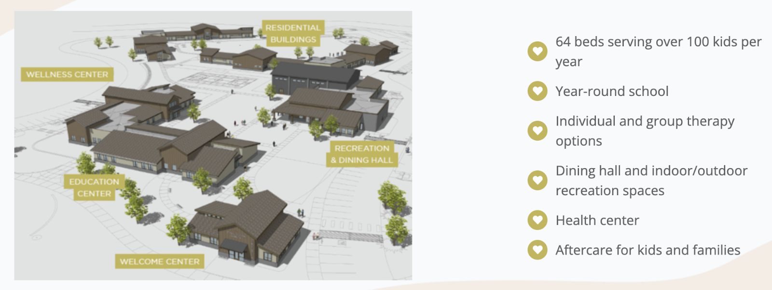

 Contact Information

School Board Chair

Scott Curtis

scurtis@youthranch.org

208-377-2613

**Non-Discrimination Statement**

Promise Academy does not does not exclude, deny benefits to, or otherwise discriminate against any person on the grounds of race, color, national origin, sex, religion, age, disability, political beliefs, sexual orientation, marital or family status or on the basis of disability in admission to, participation in, or receipt of the services or benefits of any of its programs and activities or in employment therein, whether carried out by  Promise Academy directly or through a contractor or any other entity with whom Promise Academy arranges to carry out its programs and activities.

This statement is in accordance with the provisions of Title VI of the Civil Rights Act of 1964; Section 504 of the Rehabilitation Act of 1973; the Age Discrimination Act of 1975; the Regulations of the U. S. Department of Health and Human Services issued pursuant to the Acts, Title 45 Code of Federal Regulations Part 80, 84, and 91; Title IX of the Education Amendments of 1972; and the Regulations of the U. S. Department of Education, Title 34 Code of Federal Regulations Part 106 and The Individuals with Disabilities Education Act of 2004.

**TABLE OF CONTENTS**

Executive Summary 2

Mission and Core Values 3

Educational Program 4

Student Achievement Standards 5

Key Design Elements 5

Curriculum, Tools, and Instructional Methods 6

Strategies for Serving All Students 7

Professional Development Plan 8

Financial and Facilities Plan 8

Transportation 10

Food Service 11

Financial Management and Monitoring 11

Facility Plans 13

Board Capacity and Governance Structure 16

Board Member Qualifications 17

Board Transition Plan 17

Board Recruitment and Training 18

Student Demand and Primary Attendance Target 19

Community Need and Market Interest 20

Enrollment 21

Leadership and Management 22

Supporting Documents 24

Appendix A Budgets and Cash Flow 24

Appendix B Bylaws 31

Appendix C Board of Directors 32

Appendix D School Administration 33

Appendix E Education Service Providers - **Not Applicable** 34

Appendix F Additional Supporting Documents 35

Draft Calendar 36

**EXECUTIVE SUMMARY**

Idaho has only one Psychiatric Residential Treatment Facility (“PRTF”), a non-hospital facility providing inpatient care to youth under 21 and on Medicaid, serving a limited number of 13–18-year-old girls (no boys). The other 35 PRTFs authorized to treat these Idaho youth are in other states, forcing hundreds of Idaho families to send their children out-of-state for life-saving treatment each year, adding to the child’s trauma and decreasing family engagement during treatment. The Idaho Youth Ranch (“IYR”), in partnership with this proposed charter school - Promise Academy, offers a solution to this challenge: the Residential Center for Healing and Resilience (“Residential Center”) located on IYR’s 258-acre Hands of Promise Campus. IYR is currently constructing the Residential Center, including the Education Center that will house Promise Academy. Promise Academy will serve the fifty to sixty youth, ages 11-17 residing at the Residential Center at any given time. Youth will typically reside at the Residential Center, and enroll in Promise Academy, for 6-9 months. Because students will enroll - and disenroll - on a weekly basis, coinciding with the start and completion of their treatment, Promise Academy will serve 100-120 students over the course of a year. Promise Academy is proposed as an Alternative Charter School with a year-round calendar. Given the highly individualized needs of the students Promise Academy will serve, establishing Promise Academy as a mission-specific charter school, rather than temporarily placing these youth in the traditional education system where the Residential Center is located, best sets these youth up for educational and life success.

Promise Academy’s **educational program** acts as an extension of the Residential Center and is designed to meet the specialized needs of at-risk students: (1) Mastery Based Individualized Learning Plans: Promise Academy will utilize research-based assessments upon enrollment to customize each student’s individualized learning plan. (2) Blended Learning: Promise Academy will provide a combination of direct small group instruction, guided independent study, and supervised online coursework. (3) Life Skills: Promise Academy students will learn new skills, routines, and habits to prepare them for educational success as they return to their home school. (4) Post-Enrollment Continuity and Support: Students will exit Promise Academy with a Next Steps Learning Plan shared with their home school team. (5) Year-Round: Promise Academy will operate year-round (See Draft Calendar in Appendix F) with a daily schedule closely integrated with the treatment environment.

Promise Academy’s **student outcome expectations** include: Promise Academy will conduct baseline academic assessments for grade level standards proficiency, and performance grade level equivalency. Students will be progress monitored during their time at the academy. Students will either maintain proficiency on state assessments or meet trajectory growth goals set by the state of Idaho.

The Board of Promise Academy will hire a qualified education professional to serve as the School Leader. IYR has committed to employ the School Leader for a one-year ‘Planning and Start-Up’ period (July 2022-June 2023) prior to Promise Academy opening in July 2023. Promise Academy is **organized and structured** under the Idaho Nonprofit Corporation Act. Promise Academy is incorporated and registered with the Idaho Secretary of State as a nonprofit entity in good standing. Promise Academy is governed by a volunteer Board of Directors pursuant to the Articles of Incorporation and Bylaws filed with the Idaho Secretary of State.

**MISSION AND CORE VALUES**

Promise Academy will fulfill its educational mission in close partnership with the Idaho Youth Ranch (IYR), Idaho’s largest state-wide nonprofit, as detailed throughout this Petition and pursuant to a Memorandum of Understanding between Promise Academy and IYR. Given Promise Academy’s close relationship with IYR, following are the mission statements for Promise Academy and Idaho Youth Ranch:

**School Mission Statement:** United with the Residential Center team we nurture academic growth for our youth on their journey to hope, healing and resilience.

**IYR Mission Statement:** We unite for Idaho's youth by providing accessible programs and services that nurture hope, healing, and resilience.

**Core Values Shared by IYR and Promise Academy**

Core Values of IYR and Promise Academy: (1) Relationships are the foundation; (2) Commitment to our mission unites us; (3) Growth is always possible; (4) Compassion is our lens; (5) Transparency makes us stronger; and (6) Joy sustains us.

**EDUCATIONAL PROGRAM**

**Educational Philosophy**

Promise Academy is founded on the belief that youth in residential treatment should have access to an exceptional, individualized educational experience designed to meet each student’s unique needs and situation. High quality education fosters the development of self-regulatory, relational, and cognitive skills, and is empowering. Because Promise Academy is specifically designed to serve these youth, it will meet their educational needs while also supporting and enhancing their therapeutic goals. Finally, Promise Academy will also actively work to prepare students for continued educational success as they leave the Residential Center and return to their home school and home life.

Promise Academy will operate with four guiding principles:

Principle 1 Promise Academy will engage youth with a specialized education program and experience tailored to meet their individual needs and the youth will participate in academic goal setting.  Promise Academy will reflect the practices of youth-guided and family-driven care that is in place at the Residential Center. A complete array of educational opportunities will be available.

Principle 2 Promise Academy will provide the skills, tools, plans, and supports these vulnerable youth need in order to meet longer term academic (and life) goals once they return to their home schools.

Principle 3 Promise Academy’s educational programming will be thoughtfully integrated into each student’s therapeutic treatment and schedule. Students must be making therapeutic progress (feel safe, be stable, trust adults/teachers) for learning to occur.

Principle 4 Promise Academy, along with the Residential Center, will be integrated with the Middleton area community through strong partnerships that open many campus features and opportunities to students of the Middleton School District. Likewise, Promise Academy/Residential Center youth will have opportunities to participate in community activities and events. Staff will work to identify community resources, educate them about the youth in the program and the role of the community resource in their treatment, and establish mutually agreeable expectations for youth in the program to access their resources, whether individually or for group activities.  Promise Academy’s students and the community will benefit from these partnerships and shared experiences.

**Student Academic Achievement Standards**

Promise Academy staff will create an Individualized Learning Plan (ILP) for each student which will include a plan for earning credits or credit recovery, as appropriate given each student’s unique situation. Baseline assessments will be conducted to determine proficiency at grade level and grade level performance equivalency. Proficiency assessments will include the Shortened Interim Comprehensive Assessment (SICA) and Interim Block Assessments (IBA) provided by the State of Idaho. These assessments will determine a students’ baseline level of grade level proficiency and will also be used to determine growth toward mastery of state standards. The SICA assessment will be given as a baseline and exit, with the IBA’s given at 90 day intervals during the students’ time at the Academy. Promise Academy will use these performance level assessments to determine a student’s current grade level performance and to identify gaps in learning. An assessment tool such as Mobymax will be used daily to monitor progress toward filling in learning gaps. As part of its dis-enrollment process, as students return home, Promise Academy will communicate each student’s ILP, SICA/IBA data, performance level data, credit completion or progress toward credit completion and general class level performance will be communicated with their home school. Promise Academy will also share suggestions for interventions to ensure continued success.

**Key Design Elements**

The Core Aspects of Promise Academy’s Educational Program were developed based on the specific educational needs of students receiving treatment at the Residential Center. Team members from IYR, collaborated with charter schools serving residential facilities from across the country to identify best practices. Based on these efforts over the past two years, the following Core Aspects of Promise Academy’s educational program were developed:

(1) Blended Learning: Promise Academy will provide a combination of direct small group instruction, guided independent study and supervised online coursework. Students will participate in cross-curricular and cross grade level instruction as part of the regular instructional program. Peer tutoring and peer mentoring will be embedded in the instructional program of Promise Academy. Educational staff will work with the program staff in the school to implement social emotional learning.  Staff will be trained to understand relevant science, such as the sequence of engagement, and the importance of building in self-regulation activities so that academic learning can proceed.  Staff will be aware of the individual plans for the youth and implement social-emotional interventions in the plan that will help the youth in their academic pursuits.

(2) Mastery Based Individualized Education: Each student will have the opportunity to learn content at a pace that makes sense to them. Promise Academy will utilize research-based assessments upon enrollment to customize each student’s learning plan. By offering individualized, differentiated learning plans to each student, students will have the opportunity to master content they already know, focus on skills and standards they are learning, and to evidence mastery of standards through formative and summative assessments.  Grade level core instruction and intervention instruction will be provided as necessary according to the assessment data. Each student will have access to caring, engaging instructors and staff members who understand trauma informed education. The academic program will work closely with the therapeutic program to ensure that students are fully supported and receive a seamless learning experience. Physical education, art, music, drama, shop, outdoor experiential learning, and other electives will be integrated into the curriculum.  Some of these classes well integrate therapy with instruction, for example drama, music, and art therapies.  Content experts and specialized instructors, psychoeducational therapists, and facilitators will be contracted as needed to provide such academic enrichment opportunities.  Special school events will be planned in conjunction with youth achievement in these elective pursuits, for example theater performances, student concerts, etc.

 (3) Life Skills to Carry Forward: Promise Academy will help students build the mindsets, skills, and attitudes that enable them to succeed in school and in life. Students will learn to understand themselves, connect with others, and work together.  Specific skills for operating within a school environment will be taught, practiced and progress monitored. Standards and expectations for student behavior will be crafted with student input where appropriate. Prevocational training opportunities will be provided as part of the classroom program.  These will synthesize classroom learning with work opportunities on campus and in the community.  These will simulate a real-world work experience, helping the youth to learn the basic skills needed in any employment situation; punctuality, following supervisor instructions, getting along with co-workers, completing assigned work tasks, asking for help when needed, etc.  Community partnerships will be leveraged to create specialized prevocational opportunities.

(4) Post-Enrollment Continuity and Support:  Each student’s ILP, SICA data, performance level data, credit completion or progress toward credit completion and general class level performance will be communicated with their home school. Suggestions for interventions to ensure continued success will be shared with appropriate staff at the home school as well as parents.

(5) Year-Round Instruction - Daily Schedule to Accommodate Treatment

Promise Academy will operate on a year-round basis with a calendar that corresponds to the scheduling requirements of the therapeutic programming of the residential facility. The children in the residential treatment center will greatly benefit from organization and structure in their day-to-day routine. Traditional public-school calendars are a one size fit most approach. That approach works well in traditional school settings but is disruptive and counterproductive in the unique context of a residential treatment center for emotionally disturbed children. Promise Academy’s academic program will be flexible and support the need for students to be scheduled for therapy sessions during the traditional ‘school day’. This approach provides the continuity, consistency and predictability needed in the lives of the children in residence, it is critical to have a school seamlessly integrated into the treatment programming.

**Curriculum, Tools and Instructional Methods**

Academic learning at Promise Academy will be aligned to the Idaho State Standards and will provide highly rigorous, learner-centered, differentiated learning. Promise Academy class size will average fewer than 12 students and courses will correspond with students' individual learning plans (ILP). Under the guidance of the academic/career counselor, students will understand why they are taking particular courses and how the courses are connected to their goals. All highly qualified faculty will be well informed of students’ plans in order to support instruction and differentiation. Grade level curriculum in core subjects will be utilized. Promise Academy, led by the School Leader, is undertaking a comprehensive search to determine the best state approved curriculum provider for this application. Promise Academy will select and purchase the curriculum well in advance of serving students in FY24. The chosen curriculum will provide intervention lessons and English Language Learner lessons as support for each unit. Promise Academy will provide access to devices such as chrome books to fully engage with the curriculum. Promise Academy will utilize administrative software to limit the sites students can visit online. The Academy will utilize a Learning Management System and is currently considering Canvas (or a comparable LMS), to centralize the instructional sites that students visit and provide an electronic platform for turning in assignments. Instructors will house significant portions of instructional materials on this platform. Instruction will be engaging with significant opportunities for hands-on learning. The guiding questions for each lesson will be: How will the students see the lesson? How will they hear the lesson? What will they do with the knowledge they learn?  There are many ways to answer these questions, but in answering these questions Promise Academy will ensure that students are staying engaged with the material. The instructional model at Promise Academy will focus on the following elements: Individualized instruction, differentiated assignments and assessments, different expectations for different students even with the same assignment, aligned objectives with different ways of achieving those objectives, and emphasis on personal growth from different starting points.

**Strategies for Serving All Students**

Promise Academy will be uniquely equipped to serve special populations due to its small student population size, and the resources and staff experience Promise Academy will access through its close partnership with the IYR Residential Center, as well as through hiring a highly qualified, experienced education team at Promise Academy. Promise Academy’s year-round calendar expands access to services for all students. Promise Academy recognizes each student's learning path is individual and will serve students with diverse cognitive, physical, and social and emotional needs. This will include:

* English Learners (EL).
  + Promise Academy will apply the federal definition of English Language Learner (ELLs) as defined by Title III and IX of the ESEA. The school will use a home-language survey upon student’s enrollment.  Students for whom English is a second language will be assessed using the ELL placement test.

* Special Education students with intellectual, social-emotional, and physical disabilities.
  + The Board of Directors will annually adopt the Idaho Special Education Manual with all subsequent revisions. Special education policies and procedures will be developed and implemented in accordance with the mandates of the Individuals with Disabilities Education Act (IDEA), other federal laws, and Idaho state laws. The Idaho Special Education manual will also be used for identifying, evaluating, programming, developing Individual Education Plans (IEP), planning services, discipline, budgeting, and providing transportation for special needs students as necessary. Promise Academy’s budget and staffing plan include hiring a highly qualified special education teacher who meets Idaho state requirements. Promise Academy is currently constructing physical facilities that are accessible to all and permit access to students with disabilities. All special education personnel will be selected, hired, trained, and in the classroom by the first day of the school year.

* Gifted and Talented Learners
  + Promise Academy will collect as much academic and behavior data as possible from the home districts of our students. When crafting each ILP, Promise Academy will consider the individual needs of students concerning scheduling and accommodations.

* Students on 504 plans
  + Each student will receive equal access to educational opportunities. All students will learn in the least restrictive environment in the general education classes. Teachers will modify, differentiate, and accommodate for individual students’ learning needs, meeting requirements of all 504 plans.

**Professional Development Plan**

Promise Academy’s success depends on a highly trained staff that has expertise in several areas beyond their classroom/subject area training. Instructors and staff will be trained annually on trauma informed educational strategies as well as de-escalation strategies. Instructional staff will receive annual training on engaging instructional strategies as well as effective classroom management strategies. Instructional staff will take all state required literacy, Math, and students with dyslexia trainings. We will explore shared opportunities for professional development with the Middleton District. All instructional staff will create Individual Professional Learning Plans. The IPLP will outline how the teacher/staff member hopes to advance their practice with professional growth goals and a plan for meeting those goals. These goals will connect to the observation and evaluation cycle utilized based on the Danielson Framework as required by the Idaho SDE.

Given Promise Academy’s small size - a maximum of 64 students - at capacity, Promise Academy will have a staff of 6. Accordingly, the Academy, and more specifically the School Leader, will develop and implement a highly focused and individualized professional development plan for each educator aligned with the priorities identified above. Further, the School Leader will develop a daily schedule and yearly calendar that includes ample time for planned professional development. By providing high-quality professional development and time for the Professional Learning Community (PLC), teachers will be better able to help all Promise Academy students reach their potential. Promise Academy’s PLC time will be used to foster a positive school culture and community of leaders working to improve educational aspirations and achievement for its students.

In addition, Promise Academy staff will participate in training provided by the Residential Center. These trainings will focus on understanding and working with youth with Serious Emotional Disturbances including trauma-informed educational strategies as well as de-escalation strategies, mirroring the strategies used in the Residential Center setting. All staff will be trained in in an evidence-based behavior management model and use the approach in individual educationally focused counseling as well as in classroom management. When this model is used in both the Residential Center and Promise Academy, the common language will lend consistency and predictability to the work occurring through more formal therapy services as well as at school, in day-to-day life in the living environment. The skills then carry over at home and in the community.

**FINANCIAL AND FACILITIES PLAN**

**Fiscal Philosophy and Spending Priorities**

Promise Academy’s philosophy on financial management is to maximize the expenditure of available resources on services and supports that benefit students, while maintaining spending flexibility needed to manage any unanticipated financial events. Promise Academy knows that proper financial stewardship is an essential element of a successful school. Proper financial stewardship begins with prudent and balanced multi-year financial plans, as presented in this Petition. Proper financial stewardship at Promise Academy also includes skilled financial management and oversight, as detailed below.

**Sound Understanding of Public Charter School Finances**

Through its partnership with IYR and via support from Bluum’s Charter School Finance Team, as discussed below, Promise Academy is in the fortunate position of having the support of a deep, experienced finance team - something that would otherwise not be available to a charter school of this scale. Please see Appendix A of this Petition for the Academy’s detailed 5-year budget, including cash flows and sources of other funds. Note that, in an abundance of caution, while the Residential Treatment Center and the Academy have capacity for 64 students, the budget projections are based on an enrollment of 55 students.

Bluum has awarded Promise Academy an In-Kind Support Grant that includes significant back-office support. Back-office support includes payroll processing and other accounting services assistance with annual budget preparation and

Promise Academy’s partner, IYR, is one of Idaho’s largest nonprofit entities and has served youth across Idaho since 1953.  IYR will be providing additional accounting and finances support to the Academy. IYR has a strong, experienced finance team that oversees an annual budget exceeding $31,000,000, including 400+ employees. Included with this Petition is a commitment letter from IYR stating that the IYR finance team agrees to provide fiscal management services to Promise Academy. This commitment will be formalized in the Memorandum of Understanding (MOU) IYR and Promise Academy will enter following Petition approval. The resume of IYR’s Chief Financial Officer is included in Appendix F of this Petition. In contrast with the larger IYR entity’s scale, Promise Academy is anticipated to have an annual budget of approximately $650,000 and 6 employees. The IYR team is more than prepared to assist with the management of a budget of Promise Academy’s scale and complexity.

In addition to the depth of the IYR finance team, Promise Academy’s School Leader will be an experienced public-school administrator who has managed school budgets annually for several years. The School Leader will bring this expertise to Promise Academy and will build on their existing knowledge base by attending trainings and webinars related to Idaho school budgeting and finance.

Promise Academy’s Financial Plan submitted together with this Petition was prepared by Bluum and IYR’s finance team. The Bluum finance team finds it well reasoned and well supported. The Financial Plan is designed to satisfy, among other financial best practices, the following metrics:

* Ensures timely and accurate reporting of all financial activity as required by federal and state agencies.
* Ensures timely and accurate reporting of all financial activity as required by nonprofit grantmaking organizations.
* Empowers Promise Academy’s school leader and board in their financial and operational decision-making.
* Achieve 30 Days Cash on Hand (DCOH) by completion of Year 2.

The Bluum support also includes 40 hours of Strategic Planning and Governance support during FY23 and FY24 to ensure sound financial planning and performance. These support efforts will be led by Bluum’s Director of School Strategy and Operations, Keith Donahue. Mr. Donahue is an experienced charter school board member and served as Executive Director of both Sage International School of Boise (980 K-12 students) and Forge International School in Middleton (380 students) for several years. Mr. Donahue has been a valued strategic partner in the drafting of this Petition.

**Transportation Plan**

The students in Promise Academy’s primary attendance zone will live at the Residential Center on the IYR’s Hands of Promise Campus. Promise Academy is also located on the Hands of Promise Campus. Because Promise Academy is in the unique position of having these students reside on the same campus as Promise Academy, regular home-to-school transportation services are not required. This situation benefits Promise Academy’s financial capacity and, ultimately, the students served by Promise Academy. Specifically, charter schools are reimbursed approximately only 65% of their home-to-school transportation costs, resulting in a significant, annual financial cost for each bus route. The Academy will not incur this annual expense given the unique situation of being located where the students are living. For context, a year-round charter school operating two bus routes would incur approximately $50,000 in annual out-of-pocket expense. Because the Academy will not incur this annual expense, these funds will be directed toward educational programming.  Transportation for secondary and tertiary zone students will not be provided.

While Promise Academy will not offer daily home-to-school bussing given the school’s location on IYR’s Hands of Promise Campus, per IYR’s commitment letter provided with this Petition, IYR will make available to Promise Academy buses and vans that will transport Promise Academy students for field trips, community events and for other transportation needs of the students. IYR vehicles will be equipped to transport students with special needs. Promise Academy will ensure that any/all applicable transportation needs identified in a student’s IEP are met in accordance with the requirements of state and federal law using the best method of transportation. The MOU between IYR and Promise Academy, to be executed following Petition approval and prior to Promise Academy operating, will detail this transportation partnership and support from IYR.

**Food Services Plan**

IYR will provide all students attending Promise Academy, within the primary attendance zone, with breakfast and lunch. IYR is currently constructing the Residential Center, including a kitchen and dining hall with capacity to serve daily meals well in excess of the number of students Promise Academy will serve. The Facility Plan section below provides more information, including a diagram, regarding the kitchen and dining facilities IYR is currently constructing and that will serve Promise Academy students.

Similar to other items identified in this Petition, the Academy and IYR will enter an MOU that defines these roles and responsibilities following Petition approval and well in advance of Promise Academy opening its doors to students in July 2023. Also similar to other items in the Petition, the Support Letter provided by IYR includes their commitment to partner with Promise Academy to ensure all students receive meals while attending the school.

**Financial Management and Monitoring Plan**

The Promise Academy Board of Directors will be responsible for the financial governance and oversight of Promise Academy. The Board’s financial oversight duties will be primarily fulfilled by the Board Treasurer Kimberly Thomas, the current Chief Financial Officer of the Idaho Youth Ranch. Her resume is included in Appendix C.

**The Board of Directors’ role** in financial management will include, but not be limited to the following:

Establishment of annual operating and capital budgets.

Long-term financial planning and preparations.

Monthly review of budget-to-actual financial performance providing for adequate oversight of financial performance and the opportunity to adjust expenditures as necessary to ensure operation within budget and monthly bank reconciliation sheet

Monthly review of cash flow projections.

Establishment of internal financial policies consistent with the requirements of state law and Generally Accepted Accounting Principles to provide for adequate financial controls.

Conducting an annual audit of the financial statements through the use of a qualified audit firm.

Approval of all expenditures more than $10,000.00 coupled with a monthly review of Promise Academy’s general register to verify compliance with expenditure-related policies established by the Board of Directors.

Engagement on an as needed basis as determined by the Board of Directors of accounting and/or bookkeeping professionals to meet the needs of Promise Academy in monitoring financial performance and ensuring financial viability and success.

Processes and Procedures to ensure no commingling of funds between IYR and Promise Academy. Promise Academy will maintain all financial records in accordance with Generally Accepted Accounting Principles (GAAP) and will follow all requirements set forth by the Idaho State Department of Education.

**The School Leader’s Role**

The School Leader will develop, and recommend to the Board, an annual budget in accordance with the requirements and timelines set forth by the State Department of Education (SDE). The School Leader be responsible for conducting school operations in compliance with the Board-approved annual budget. The School Leader, with support from IYR’s and Bluum’s financial teams will track the expenses and keep a ledger using a software program that will be identified during the startup planning year (FY23). The ledger will keep current expenses compared to budgeted expenses A monthly report to the board will be generated. Blank checks will be stored at the financial manager’s office in a locked cabinet. Payment of expenses will be made by check. The checks will be printed by the financial manager and sent to the administrator for review and signature. Authorized signatories will be the administrator, the board chair, and the board treasurer.

Purchasing. Subject to the approval of the Board of Directors and the policies and procedures established by the board, the School Leader will develop the procedures for procuring goods and services for Promise Academy. All purchasing procedures will comply with Idaho laws and administrative rules, including competitive bidding.

As noted above, as Promise Academy opens, the Board and the School Leader will have access to both the IYR and Bluum finance teams to provide support with respect to performance of these financial oversight duties.

**Facilities Plan - Hands of Promise Campus Overview**

Promise Academy has a defined and fully supported facilities plan. IYR is currently constructing a state-of-the art facility that includes Promise Academy, two residential halls with a 64-youth capacity, a wellness center, a welcome center, and a dining and recreation hall. The construction project will be completed ahead of Promise Academy’s opening. This construction project adds to the Equine Therapy center and IYR office buildings already located on the campus.

Below is a diagram and narrative summary of the facilities currently under construction, including the Education Center.  In designing all facilities on the Hands of Promise Campus, IYR and its partners considered IYR’s extensive experience providing treatment to at-risk youth and the team conducted extensive research, including site visits and interviews with similar residential facilities throughout the United States. The underlying design principles IYR developed through these efforts include:

* Safety of residents and staff
* Non-institutional (home-like) look & feel
* Cost effective buildings
* Durable materials
* Connection to outdoors
* Leverage site views
* Keep kids moving
* Preserve programmatic spaces
* Safety & security measures don’t impose on design principles
* Connection/interaction with community
* Maximize opportunity for future programs

Two Residential Lodges, each able to accommodate 32 youth in two wings of 16 youth each; each resident will have their own room and the lodges will have areas for group activities and socializing, entertainment, study, communication with home, and simple meal preparation and dining.

Welcome Center for greeting families, intake, orientation, and administrative functions.

Education and Wellness Center for both in-person and on-line education activities, delivery of individual and group therapy, and offices for administrative and support services. The Education Center will house Promise Academy.

Recreation Center for fitness, athletic competition, and group activities.

Kitchen and Dining Hall for cafeteria-style mid-day meals and family-style evening meals, for both large and small groups.

**Promise Academy Integration into Hands of Promise Campus**

By design, Promise Academy is connected to the wellness center, allowing for easy and efficient student access to both therapeutic and educational services. Per IYR’s website, “The magnificent 258-acre site near Middleton provides an incredible array of natural habitat and wildlife to help us create an exceptional environment for healing, including forest, streams, ponds, agricultural land, and open space. Animal husbandry, conservation projects, FFA, 4-H, organic gardening, outdoor challenge courses, camping, and trails for hiking and horseback riding are all part of the plan for the site.” Following is an image of the Education Center floor plan.

The Education Center is specifically designed to serve this special population of students and the number of students (maximum 64) that the Residential Center has the capacity to serve. Per the image, the Education Center includes six large classroom spaces, two smaller breakout rooms between classrooms, unisex restrooms in each classroom, and an entry area that includes space for storage, janitorial supplies, and an administrative office. In addition to the facilities specifically designated as the Education Center, *students attending Promise Academy will utilize all the facilities and resources on the Hands of Promise Campus while enrolled in Promise Academy*, including but not limited to the extensive outdoor spaces and resources, the Recreation Center, and the Dining Hall.

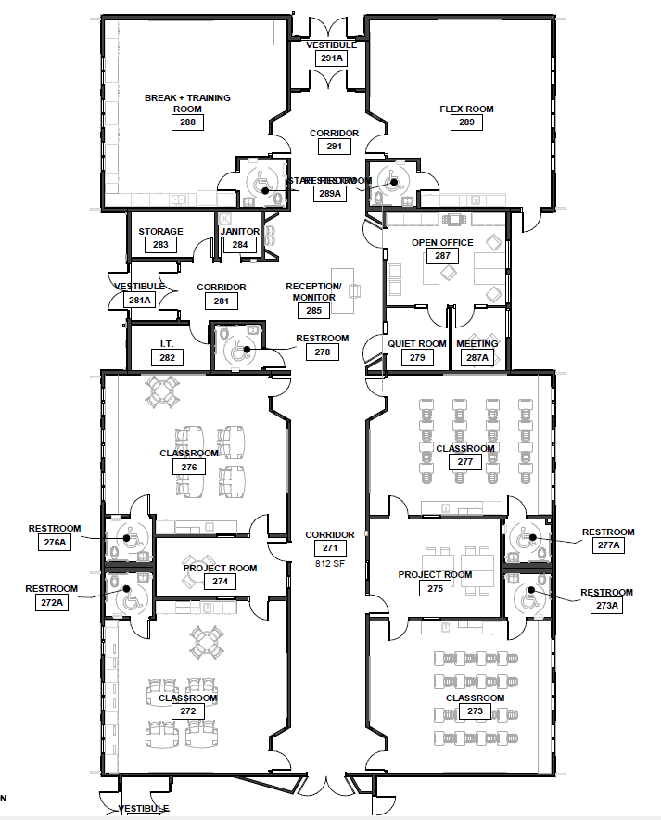

**BOARD CAPACITY AND GOVERNANCE STRUCTURE**

Strong governance is the foundation for a strong organization and a strong school. Promise Academy has established an exceptional founding Board of Directors who collectively possess a depth and breadth of skills and experiences that will enable Promise Academy to successfully serve this unique student population.

Promise Academy is incorporated as a nonprofit corporation in the State of Idaho and has adopted bylaws that have been reviewed by counsel and determined to be legally compliant and to address all necessary content. The Board of Directors understands and values the difference between governance and management. Accordingly, the Board will perform the proper functions of governance and will:

● Maintain Promise Academy’s vision and mission.

● Establish academic, operational, and financial goals.

● Adopt policies.

● Ensure the financial viability of Promise Academy.

● Hire, evaluate, and determine the compensation of Promise Academy School Leader; and,

● Comply with all applicable laws, including but not limited to laws on public information

and open meetings.

Promise Academy’s School Leader will be responsible for implementing operating practices to support Promise Academy’s vision and mission, achieve the organization’s goals, implement board policies, maintain the financial viability of Promise Academy, hire and manage all other staff, and comply with all applicable laws. The Board will monitor and evaluate how well management is implementing and achieving board policies, goals, and objectives.

**Describe Governance Structure**

Promise Academy bylaws provide for a Board of Directors comprising no less than 3 and no more than 10 members. The founding Directors are Scott Curtis, Richard Alis and Kimberly Thomas Each founding Director’s qualifications are described in the Board Member Qualifications section that follows. Board members serve staggered, three-year terms, with a limit of two terms. Initial board members are those named in the incorporating documents. Thereafter, board members will be selected by the Board pursuant to a policy developed by the Board. The Board will meet at least 4 times a year, including 1 annual meeting and three or more regular meetings, but may choose to meet more frequently. Board officers are a Chair, Vice-Chair, Secretary, and Treasurer. The Chair presides at all meetings of the Board of Directors and is an ex officio member of all committees. The Chair oversees implementation of board and organizational policies and ensures that appropriate administrative practices are established and maintained. The Vice Chair discharges the duties of the Chair in the Chair’s absence and shares other responsibilities as appropriate.

The Secretary provides direction for the keeping of legal documents including minutes of all meetings of the Board. The Treasurer provides direction for the financial management of the organization and helps the Board to meet its financial oversight responsibilities.

Promise Academy’s Board of Directors will establish and maintain the following committees:

● Governance. Key responsibilities include ensuring all trustees understand their roles and responsibilities, board member recruitment and selection, annually evaluating the full board, individual trustees, and Promise Academy leader.

● Finance. Key responsibilities include conducting proper oversight of the financial health of the organization and ensuring compliance with all applicable laws.

● Academic Excellence. Key responsibilities include ensuring that the full board and the

School Leader have a shared vision of academic excellence and a clear plan to achieve it and conduct oversight of that plan.

Promise Academy’s bylaws allow for the Board to add or modify its committee structure through board policy.

**Identify Founding Board and their Qualifications**

Promise Academy’s Board reflects diverse experiences and skills needed to support the success of Promise Academy. In building the composition of the Board, Promise Academy has considered and will continue to look for Directors with skills and experience in six areas: education, social service, finance, law, real estate, post-secondary preparedness, and residential treatment for youth. In addition, Promise Academy is working to build a board that reflects the diversity of race, ethnicity, and genders of the community served by Promise Academy. Appendix C contains the names and qualifications of each current Director.

**Transition Plan - Founding to Operating Board**

Promise Academy’s Board has been established from the beginning to provide a solid foundation, continuity, and stability for Promise Academy now and for years to come. There will not be a “founding board” that transitions to a “governing board.” There is a single, continuous board. Board members will be provided additional training, detailing how to effectively transition from a founding board to a governing board as the Academy prepares to open its doors to students in July 2023. As the school’s leadership team is hired and the school becomes operational, the Board is fully prepared to transition into a governing board’s oversight role, with the School Leader having responsibility executing the board’s strategic and budget plans and managing day-to-day operations. In addition to this training, the Board Policies adopted by Promise Academy will include Governance Policies that outline the Board responsibilities and School Leader responsibilities and clearly define the critical relationship between the Board and School Leader.

None of the founding members of the Board intends to resign in order to apply for a paid position at Promise Academy. Consequently, there is no risk to the Board or Promise Academy of founder’s syndrome derailing the governance of Promise Academy.

Promise Academy’s Articles of Incorporation and Bylaws are included in this document as Appendix C.

**Board Recruitment and Training**

Recruitment Approach.

Promise Academy has identified a set of board member qualities, skills, and experience that will enable the school to thrive for years to come, and has been using those attributes to identify, recruit, and select board members. Board members will have diverse backgrounds.

Training Approach.

Promise Academy has relationships with two organizations to provide for ongoing training of board members: Bluum and the Idaho School Boards Association. The expertise of these organizations is complementary: Bluum has Idaho school-specific expertise in the areas of governance and finance for new (launching) charter schools; ISBA has expertise in Idaho school law, policies, and requirements. Promise Academy’s Board of Directors will use Bluum’s Charter School Governance Guide (<https://www.bluum.org/charter-governance-guide/>) and the Idaho School Board Association’s “School Board Professional Services,” including its Professional Development Modules and its many resources in its New Board Member Packet: Code of Ethics, Basics of Governance, 8 Characteristics of an Effective Board Member, and more. Both Bluum and ISBA offer board trainings throughout the year, including ISBA’s annual 2-day Conference; Promise Academy board members will be encouraged to participate in these training opportunities.

Promise Academy will provide all board members with a ‘New Board Member Packet’ that will serve as the foundation for on-boarding new board members. New board members will also meet with appropriate school staff to learn the history, educational program, finances, and legal obligations of Promise Academy. The Board will conduct ongoing self-assessments (surveys) that will include opportunities for Promise Academy leader, School staff, and School community to provide feedback to the Board on the strengths and weaknesses of Promise Academy and the Board.

**STUDENT DEMAND AND PRIMARY ATTENDANCE AREA**

**Primary Attendance Area**

.

The primary attendance zone for Promise Academy consists of the 258 acres that make up the Hands of Promise campus at the Idaho Youth Ranch in Caldwell, Idaho.

**Secondary Attendance Zone**

The secondary attendance zone for Promise Academy is the Middleton School District

**Tertiary Attendance Zone**

The tertiary attendance zone for Promise Academy is the rest of the state of Idaho.

Students will be admitted to Promise Academy in accordance with section 33-5206 of Idaho State Code: REQUIREMENTS AND PROHIBITIONS OF A PUBLIC CHARTER SCHOOL.

**Community Need, Demand, and Market Interest**

Promise Academy is established to serve youth from all over the Gem State while these youth reside at the Idaho Youth Ranch Residential Center for Healing and Resilience, typically for a 6–12-month period before returning home. The Residential Center will serve youth who have been determined to have a serious emotional disturbance (SED) which is typically caused by a history of childhood trauma and diagnosed as requiring therapeutic residential treatment. The determination that a youth has a SED has usually led to a situation where a youth is unable to function well in their school and community.

The Idaho Youth Ranch has worked closely with the Idaho Department of Health and Welfare and the State of Idaho Medicaid office to identify the need for the Residential Center to be opened in Idaho. In any given month 6-8 youth are approved for placement in a PRTF in addition to the approximately 120 youth who are, at any given time, already living in a PRTF outside of Idaho. The Idaho Department of Health and Welfare says they could easily fill the Residential Center - and thus the school - and keep it filled indefinitely based on the number of youth in out-of-state treatment facilities and those on the waiting list. The ability to place these youth in a facility and school in their own home state will result in better outcomes for both their mental health treatment and their educational progress. Parent involvement (made more practical and meaningful by proximity) is a top predictor of success in both areas.

**Community Partnerships and Local Support**

Given the vulnerable, underserved student population the Academy will enroll, the Academy has strong support partners in the community and statewide. Philanthropic leaders across Idaho have contributed over $27M to establish the Residential Center, which includes the Education Center that will house the Academy. The Middleton School District and the Academy will have a relationship which mutually benefits both the student population and the school staffs. The entities will enter an MOU once the petition has been approved that describes the collaboration in more detail. The Academy has also had conversations with The Peregrine Fund, the Boise Astronomical Society, and the Idaho Stem Action Center regarding providing educational opportunities for students. IYR’s current collaborations with the Boy Scouts of America, the Y, Ride for Joy, the Caldwell Night Rodeo, and other organizations will also extend to the Academy.

**Informing Underserved Students and Families About the Academy**

Promise Academy is structured as an alternative school with a focus and mission to serve at-risk students. Promise Academy will, in fact, serve the most vulnerable students in the state of Idaho; those students who have been identified as having a Serious Emotional Disturbance.  All students at Promise Academy will be diagnosed as requiring therapeutic residential treatment. Traditionally at-risk students, and particularly students with Serious Emotional Disturbance, are an underserved population. The intent of the charter is to focus primarily on underserved youth. Promise Academy will be guided by IDAPA code defining at-risk youth.

During the enrollment phase, every student attending Promise Academy will have a one on one intake meeting with school leaders. This meeting will focus on the individual needs of each student and determine their at-risk factors as determined by the Idaho State.

**Enrollment Capacity**

Promise Academy’s enrollment capacity is determined by the maximum capacity at the residential facility on campus. Maximum capacity of the facility, and therefore the Academy, is 64 students ages 11-18. Promise Academy is presenting a single capacity figure of 64 students, rather than a grade-by-grade breakdown of students given the population Promise Academy will serve. These students, aged 11-18, will arrive at varied levels from an academic perspective that does not necessarily correlate with a student’s age.

**Enrollment Table**

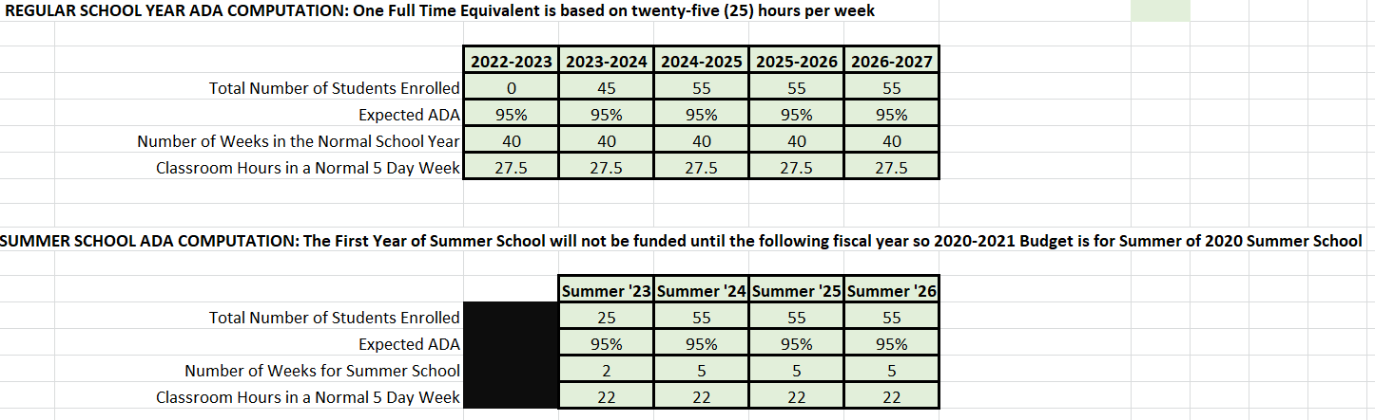

**Virtual and Blended Programs (if applicable)**

        NA

**ACADEMY LEADERSHIP AND MANAGEMENT**

**Promise Academy Leadership Structure**

The academy will be led by an experienced school administrator with significant experience serving an at-risk student population. IYR will employ the School Leader for the current fiscal year (FY23) and will fully fund and support this position during Promise Academy’s pre-opening year to ensure a successful launch of Promise Academy. This financial investment by IYR is represented in the provided budget materials. A broad search for a School Leader has been conducted and viable candidates identified. As soon as the recruitment/hiring process has been completed, the Academy will notify the charter authorizer.

**School Leader Qualifications**

* Bachelor’s degree; Master’s level degree or above preferred
* Demonstrated effective teaching experience, preferably with alternative education or underserved students
* Successful school leadership experience preferred at the middle school and/or high school level
* Experience as an IEP process leader, including (but not limited to) supervision of program implementation, knowledge of research based instructional practices, the provision of FAPE, and the foundations of IDEA.A deep, personal commitment to supporting the mental and behavioral health of your students and an understanding of the inter-relatedness of the residential treatment program and educational program for every student
* Commitment to data-driven results
* Deep belief that all children, no matter their personal backgrounds or previous educational experience, can learn and become productive citizens
* A strong commitment to the mission and values of Idaho Youth Ranch, which will be mirrored in the charter school
* Exceptional critical thinking skills, including the ability to find solutions to what others consider insoluble problems
* Passion to thrive in a new environment with challenging opportunities and a willingness to embrace out-of-the-box thinking to make a lasting impact
* Proven ability to establish and maintain a healthy organizational culture, preferably in the context of standing up and leading a new program or organization
* Proven ability to build strong relationships across functional areas and organization levels, and commitment to quality of care and client and staff safety

**School Leader Evaluation**

The Promise Academy Board of Directors will conduct an annual evaluation of the School Leader in compliance with all state requirements and Promise Academy policies.

**Educational Service Providers - NA**

Promise Academy will not contract with an Educational Service Provider.

**SUPPORTING DOCUMENTS (APPENDICES)**

Appendix A – Budgets, Cashflow, additional funds

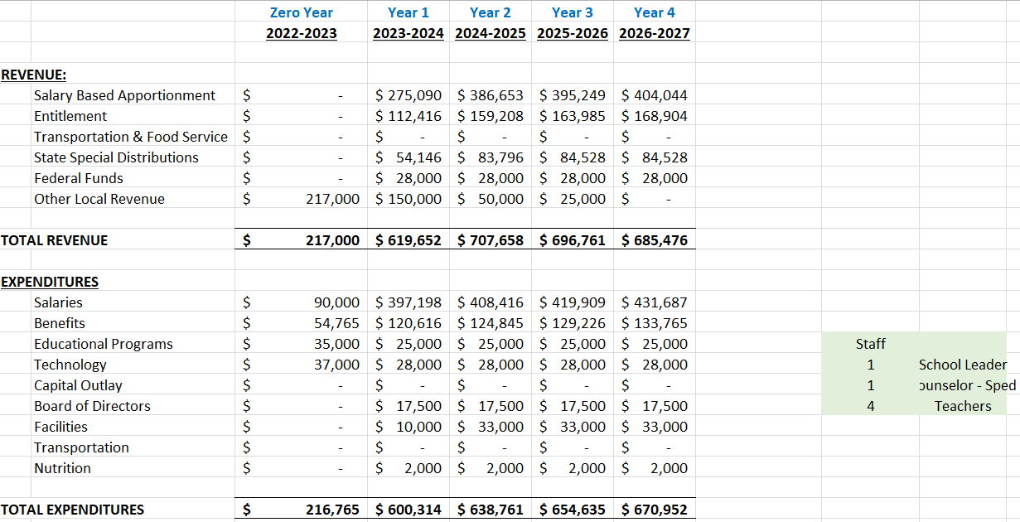



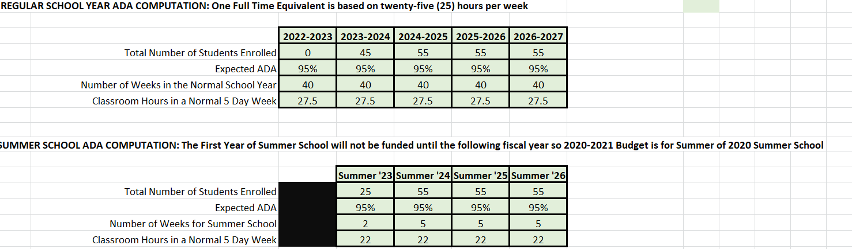

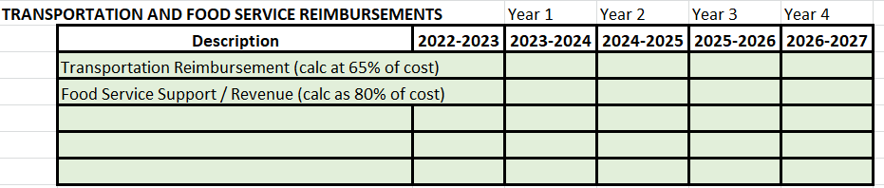

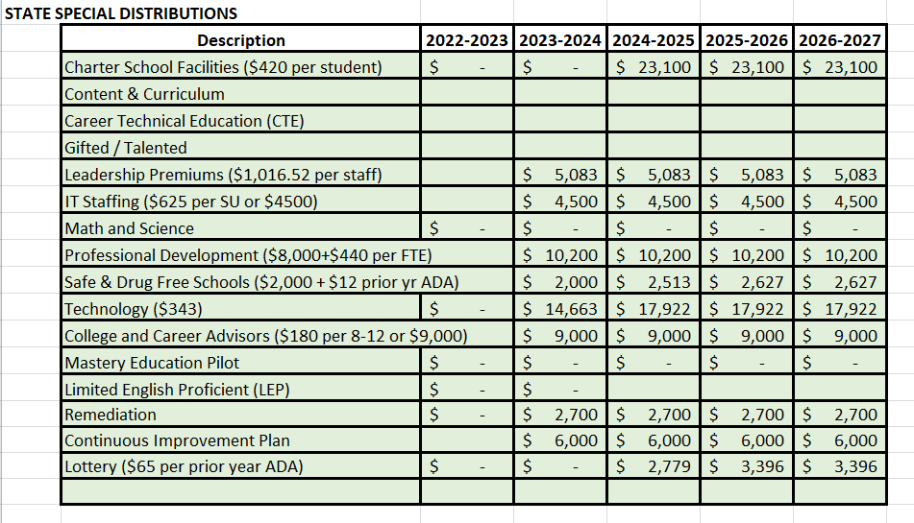

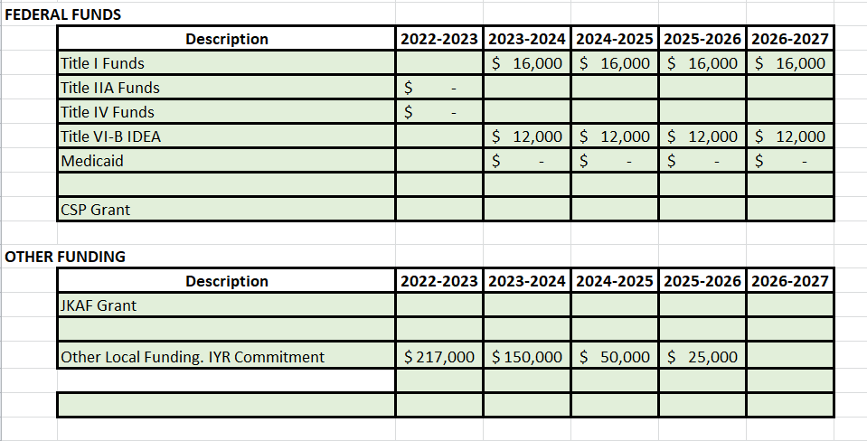

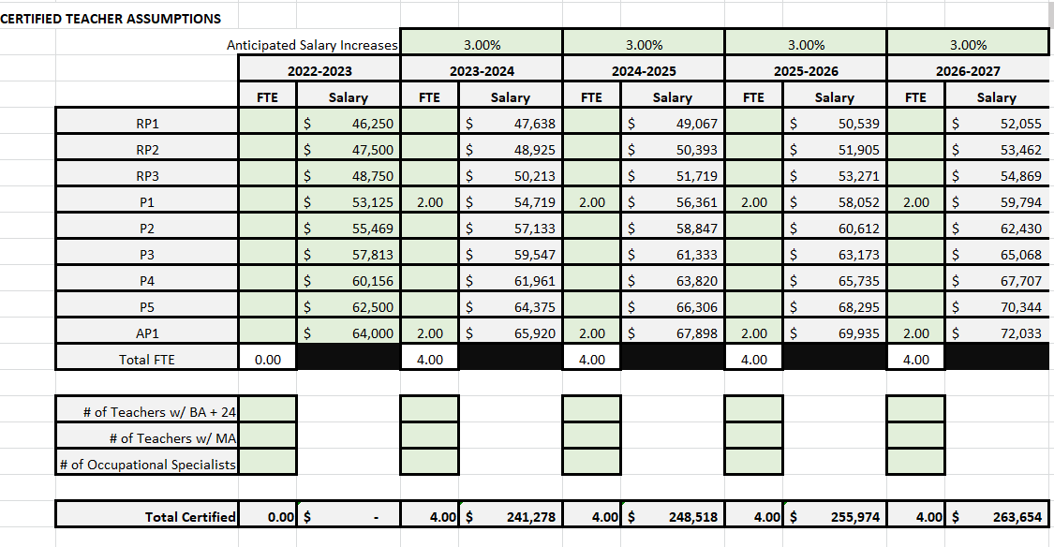

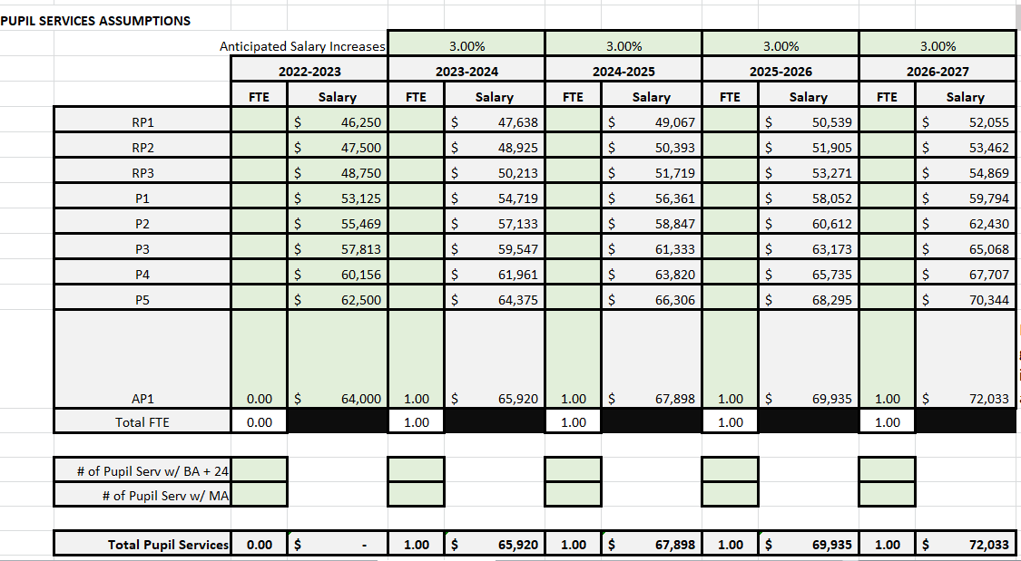

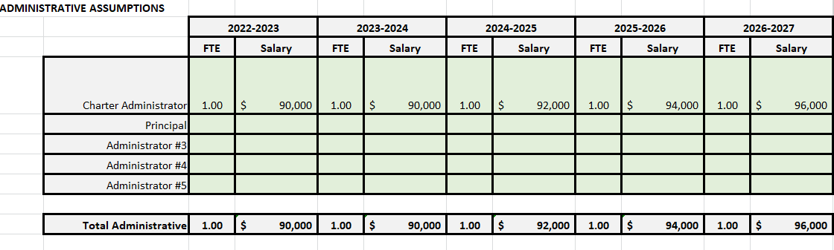

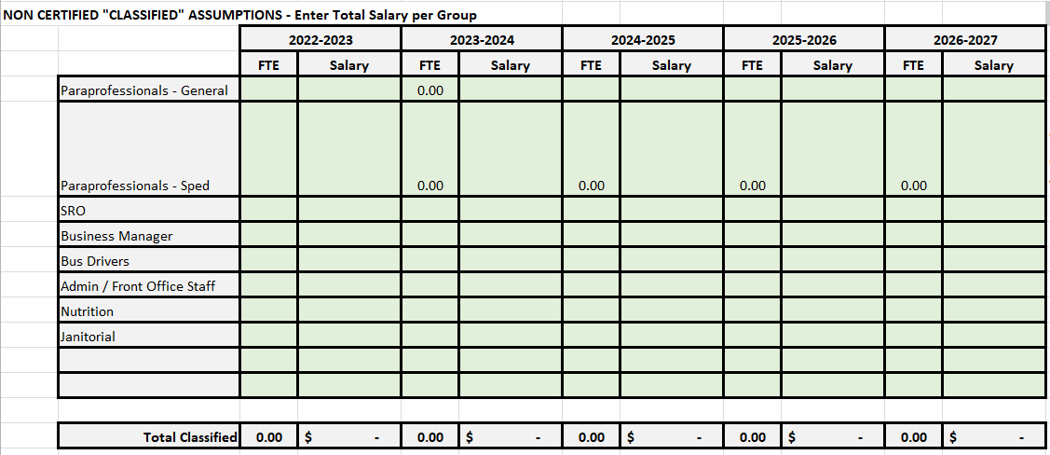

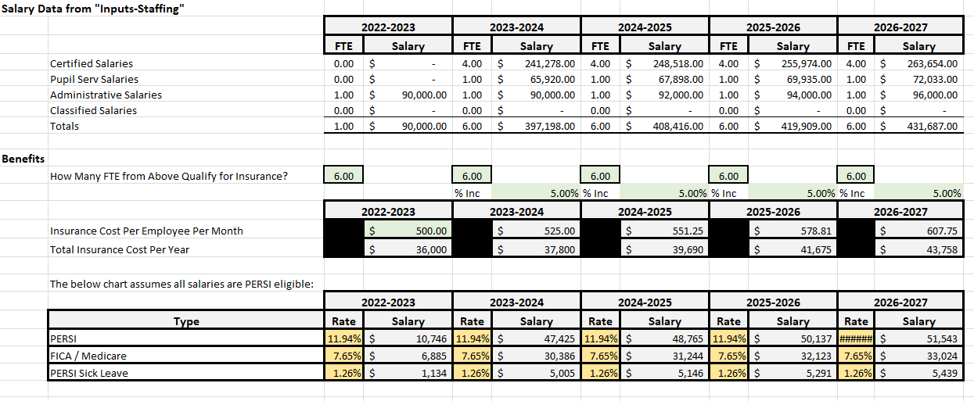

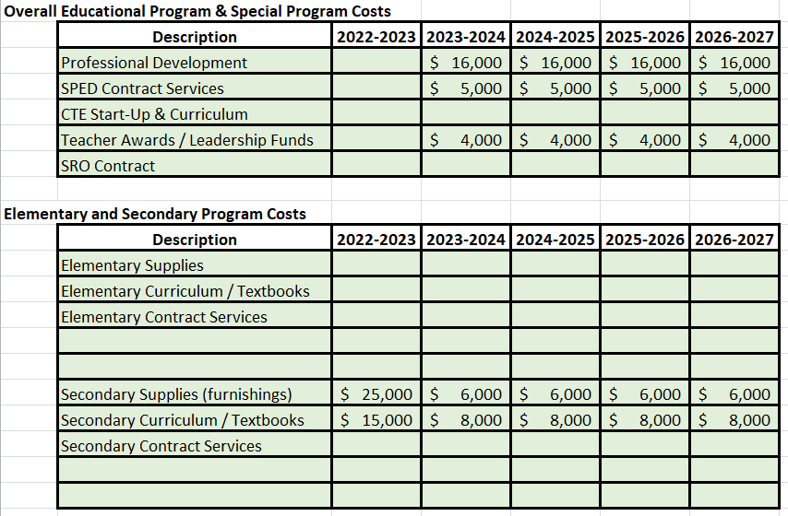

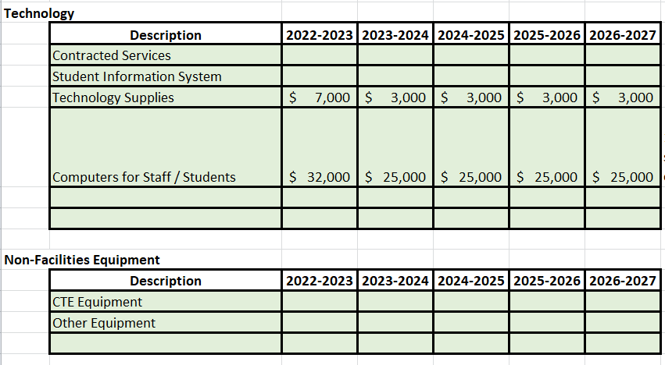

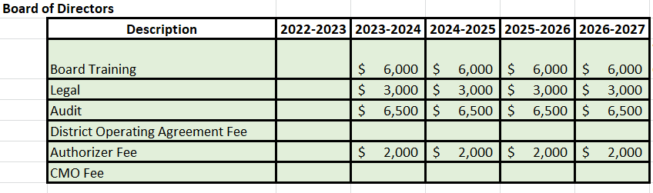

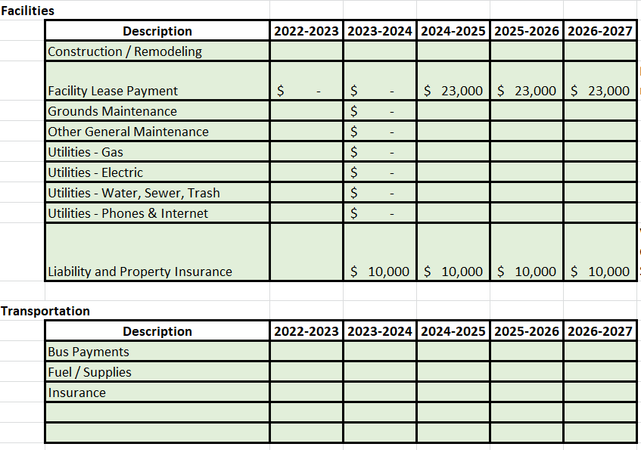

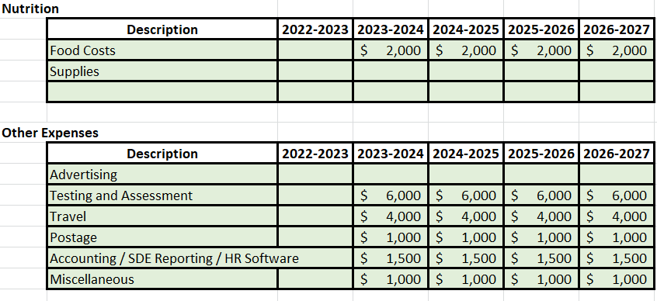

Appendix B – Articles of Incorporation and Bylaws

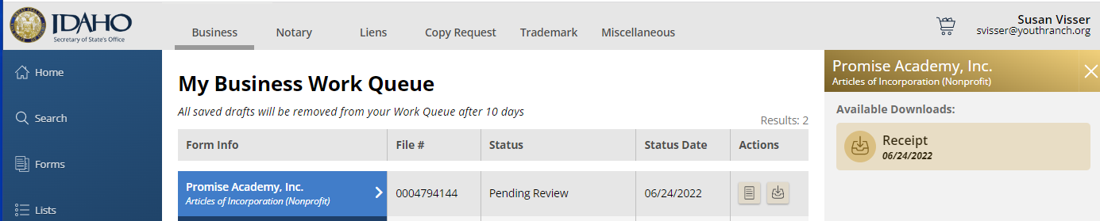

**Bylaws of Promise Academy, Inc.**

**ARTICLE 1.  NAME AND OFFICES**

**1.1 Name**

Promise Academy, Inc. (hereinafter “the corporation”) organized and existing under Title 30, of the Idaho Code.

**1.2 Principal Office**

The principal office of the corporation shall be located in Ada County, Idaho. The corporation may have such other offices, either within or without the State of Idaho, as the Board of Directors may designate or as the business of the corporation may require from time to time.

**1.3 Registered Office**

The registered office of the corporation required by the Idaho Business Corporation Act to be maintained in the State of Idaho may be, but need not be, identical with the principal office in the State of Idaho, and the address of the registered office may be changed from time to time by the Board of Directors.

**1.4 Purpose**

The corporation is organized and shall be operated exclusively for the specific purposes set forth in the corporation’s Articles of Incorporation, namely educational purposes within the meaning of Section 501(c)(3) of the Internal Revenue Code.

**ARTICLE 2.  BOARD OF DIRECTORS**

**2.1 General Powers**

The business and affairs of the corporation shall be managed by its Board of Directors.  Except as otherwise provided by law, the articles of incorporation, or the bylaws, the board of directors (the “**Board of Directors**” or “**Board**”) shall exercise, or delegate or otherwise authorize the exercise of, all corporate powers and shall direct the management of the corporation’s affairs.  The Board shall retain authority over and exercise of the corporate powers that the Board delegates or authorizes under this Section. The directors serving hereunder shall have the power, authority, and responsibilities of and shall perform the functions provided for directors under the Act, including, but not limited to, the power to do the following:

1. To appoint and control and, at its pleasure, remove any agents and employees and to allow such compensation for their services, as the Board shall deem proper.  This shall include the power to appoint investment advisors, trust companies, banks, or other fiduciaries to invest and safeguard the assets of the corporation.
2. To prescribe, consistent with these bylaws, the duties of any Officer.
3. To determine and govern all matters affecting finances, areas of focus, and the function of the corporation; and
4. To conduct such acts as may be required to carry out the charitable purposes of the corporation.

**2.2 Number, Tenure and Qualification**

The number of directors of the corporation shall consist of not less than 3 nor more than 10 persons.

During the initial year of operation, the Board shall be comprised of the Directors listed in the Articles of Incorporation and any other Directors elected by the then-current Board or appointed in accordance with these bylaws.

Directors serve for terms of three (3) years.  Directors may serve for any number of consecutive terms, subject to any policy on director term limits that the Board may from time to time establish.  Despite the expiration of a director’s term, the director shall continue to serve until the director’s successor is elected, or until the Board determines to decrease the then-current number of directors. By resolution, the Board may divide the total number of directors into groups and otherwise arrange for terms to be staggered such that not all of the directors’ terms expire in the same year.

Directors must be individuals 18 years of age or older. Directors need not be residents or citizens of the State of Idaho or of the United States of America. The Board may establish written policies that include additional criteria for qualifications of directors.

**2.3 Appointment of Directors**

During the initial year of operations, the Board shall consist of those Directors appointed pursuant to the terms of these Bylaws. After the initial year of operations Directors will continue to be appointed by a majority vote of Directors at the Corporation’s annual meeting.

**2.4 Vacancies**

Any vacancy occurring in the Board of Directors may be filled by the affirmative vote of a majority of the remaining directors, even if less than a quorum. A Director appointed to fill a vacancy shall be appointed for the un-expired term of his/her predecessor in office. Any directorship to be filled by reason of an increase in the number of directors may be filled by appointment by the Board of Directors for a term of office continuing only until the next annual meeting.

**2.5 Compensation**

By resolution of the Board of Directors, each director may be paid his/her expenses, if any, of attendance at each meeting of the Board of Directors. There shall be no salary, fixed sum, or other compensation paid to any director other than expenses of attending meetings or other authorized functions.

**2.6 Resignation**

A director may resign at any time by delivering written notice to the Board of Directors. The resignation is effective as of the date thereof unless the notice specifies a later effective date. If a resignation specifies a later effective date and the corporation accepts the later effective date, the Board may fill the pending vacancy before the effective date if the Board provides that the successor does not take office until the effective date.  Once delivered, a notice of resignation is irrevocable unless revocation is permitted by the Board.

**2.7 Removal**

A director may be removed, at any time, with or without cause, by a vote of a two-thirds majority of the directors then in office at a meeting called for that purpose.

**2.8 Committees**

The Board of Directors may create one or more committees and the Board Chair shall appoint members of the Board of Directors to chair them. Members of the committees other than the chairperson need not be directors. Each committee may have two or more members, as appointed by the Board Chair. The provisions of this Article which govern meetings, action without meetings, and quorum and voting requirements of the Board of Directors shall apply to committees and their members as well.

**ARTICLE 3.  BOARD MEETINGS**

**3.1 Annual Meeting**

The annual meeting of the Board of Directors shall be held at the time and date established by the Board of Directors. In the absence of a designation from the Board of Directors, the annual meeting shall be held on the 2nd Tuesday in June, or on such other date as the Board shall decide. The failure to hold the meeting at the time stated shall not affect the validity of any corporate action.

**3.2 Regular Meetings**

The Board of Directors may establish, by action at a meeting or unanimous written consent, the time and place for holding subsequent regular meetings of the Board of Directors. The Board of Directors shall hold no less than three (3) Regular meetings from July of each year through June of the following year.

**3.3 Special Meetings**

Special meetings of the Board of Directors may be called by or at the request of the Chair or at least three (3) directors. The person or persons authorized to call special meetings of the Board of Directors shall fix any place, either within or without Ada County in the State of Idaho, as the place for holding any special meeting of the Board of Directors called by them.

**3.4 Public Meetings**

Except as otherwise permitted by Idaho code, all meetings shall be open to the public. Pursuant to Title 33, Chapter 52 of the Idaho Code, all other provisions of Title 74, Chapter 2 of the Idaho Code shall be applicable to meetings called by the Directors of the Corporation.

**3.5 Notice and Agendas**

Agenda notices for regular meetings will be posted at least 5 days in advance, in order to comply with Idaho Open Meeting laws. Agenda items may be added subsequent to notice provided a good faith effort was made to include all known agenda items in the published notice at the time of its publication. Amendments to the agenda will follow the requirements of Idaho’s Open Meeting laws. Notice of any special meeting will comply with Idaho Open Meeting laws.

**3.9 Participation**

Members of the Board of Directors or any Committee may participate in a meeting of the Board or Committee by means of conference telephone, online video chat, or similar communications equipment by which all persons participating in the meeting can hear each other at the same time as allowed through the Idaho Open Meetings laws. Such participation shall constitute presence in person at the meeting. As the public must be able to attend phone meetings, at least one Board member or an Administrator must be present at the posted meeting location. All board meetings shall comply with the Idaho Open Meeting laws.

**3.10 Quorum**

A majority of the number of directors then in office shall constitute a quorum for the transaction of business at any meeting of the board of directors, but if less than such majority is present at a meeting, a majority of the Directors present may adjourn the meeting without further notice.

**3.11 Manner of Taking Action**

The act of the majority of the directors present at a meeting at which a quorum is present shall be the act of the Board of Directors. All actions shall comply with Idaho Open Meeting laws.

**3.12 Meeting Minutes**

Written minutes shall be maintained at all meetings of the Board of Directors. Neither a full transcript nor a recording of the meeting is required. Minutes shall be available to the public within a reasonable time after the meeting, including: (a) Names of the Directors present; (b) Motions, resolutions, orders, or ordinances proposed and their disposition; (c) Results of all votes. Minutes of any executive sessions held by the Directors of the Corporation under Title 74, Chapter 2 of the Idaho Code may be limited to material, the disclosure of which is not inconsistent with the provisions of section 74-206, Idaho Code, but must contain sufficient detail to convey the general tenor of the meeting.

**3.13 Executive Sessions**

Executive sessions, closed to any persons for deliberation on specified matters, may be held by the Board of Directors for those reasons outlined and specified in Title 74-206, Chapter 2 of the Idaho Code. Unless otherwise allowed by law, no Director may disclose the content of an executive session to an outside source.

**ARTICLE 4.  OFFICERS**

**4.1 Designation**

The officers of the corporation shall be a Chair, Vice Chair, Secretary, and Treasurer, and may include such other officers as the Board may from time to time designate.  The same individual may be elected to more than one (1) office.

**4.2 Election and Term of Office**

The officers of the corporation shall be selected from the members of the Board of Directors and shall be elected annually by the Board of Directors at the annual meeting of the Corporation. The initial Board of Directors shall select initial officers who shall serve until the first annual meeting. If the election of officers shall not be held at such meeting, such election shall be held as soon thereafter as conveniently may be. Each officer shall hold office until his/her successor shall have been duly elected and shall have qualified or until his/her death or until he/she shall resign or shall have been removed in the manner hereinafter provided.

**4.3 Removal**

Any officer or agent may be removed by the Board of Directors whenever, in its judgment, the best interests of the corporation will be served thereby, but such removal shall be without prejudice to the contract rights, if any, of the person so removed. Election or appointment of an officer or agent shall not of itself create contract rights.

**4.4 Vacancies**

A vacancy in any office because of death, resignation, removal, disqualification or otherwise, may be filled by the Board of Directors for the un-expired portion of the term.

**4.5 Chair**

At its annual meeting, the Board of Directors shall elect from among its members a Board Chair who shall, when present, preside at all meetings of the Board of Directors and ensure the Board of Directors follows appropriate parliamentary procedures. The Chair shall be the principal executive officer of the corporation and subject to the control of the Board of Directors, shall be responsible to establish the agenda for all meetings of the stakeholders of the Corporation and all meetings of the Board of Directors and ensure that all participants in such meetings have access to the materials necessary to their participation. The Chair shall serve as the chief liaison between the Board of Directors and the school administration and as the primary signing agent for all official Board documents. The Chair shall also be responsible to ensure compliance by the Board of Directors with the performance certificate, the board manual, if any, and these corporate Bylaws.

**4.6 Vice Chair**

In the absence of the Chair or in the event of his/her death, inability or refusal to act, the Vice Chair shall perform the duties of the Chair, and when so acting, shall have all the powers of and be subject to all the restrictions upon the Chair.

**4.7 Secretary**

The Secretary shall prepare or shall ensure that: (a) minutes of the proceedings of the directors and of the Board of Directors are recorded in one (1) or more books or files provided for that purpose; (b) all notices are duly given in accordance with the provisions of these Bylaws or as required by law; and shall: (c) be custodian of the corporate records, excepting the financial records; (d) keep a register of the post office address of each Board director which shall be furnished to the secretary by such board director; and (e) in general perform or cause to be performed all duties incident to the office of secretary.

**4.8 Treasurer**

The Treasurer shall: (a) serve as the chief liaison with the business manager for the school; and (b) in general perform all of duties incident to the office of treasurer.

**4.9 Salaries**

The officers shall serve without compensation other than reimbursement for expenses.

**ARTICLE 5.  CONTRACTS, LOANS, CHECKS, and DEPOSITS**

**5.1 Contracts**

The Board of Directors may authorize any officer or officers, agent or agents, to enter into any contract or execute and deliver any instrument in the name of and on behalf of the Corporation, and such authority may be general or confined to specific instances.

**5.2 Loans**

No loans shall be contracted on behalf of the Corporation and no evidences of indebtedness shall be issued in its name unless authorized by a majority vote of the Board of Directors. Such authority may be general or confined to specific instances.

**5.3 Checks, Drafts, Etc.**

All checks, drafts, or other orders for the payment of money, notes or other evidences of indebtedness issued in the name of the Corporation, shall be signed by such officer or officers, agent or agents of the Corporation and in such manner as shall from time to time be determined by a majority vote of the Board of Directors.

**5.4 Deposits**

All funds of the Corporation shall be deposited from time to time to the credit of the Corporation and in such banks, trust companies or other depositories as the Board of Directors may select.

**ARTICLE 6.  FISCAL YEAR**

The fiscal year of the Corporation shall begin on July 1 and shall end on June 30.

**ARTICLE 7.  NO PROVATE INUREMENT**

No part of the net earnings of the corporation shall inure to the benefit of, or be distributable to its directors, officers, or other private persons, except that the corporation shall be authorized and empowered to pay reasonable compensation for services rendered and to make payments and distributions in furtherance of the purposes set forth in the Articles of Incorporation. No substantial part of the activities of the corporation shall be the carrying on of propaganda, or otherwise attempting to influence legislation, and the corporation shall not participate in, or intervene in (including the publishing or distribution of statements) any political campaign on behalf of or in opposition to any candidate for public office. Notwithstanding any other provisions, the corporation shall not carry on any other activities not permitted to be carried on (a) by a corporation exempt from federal income tax under section 501(c)(3) of the Internal Revenue Code, as amended; or (b) by a corporation, contributions to which are deductible under section 170(c)(2) of the Internal Revenue Code, as amended.

**ARTICLE 8.  CORPORATE SEAL**

The corporation shall not have a corporate seal.

**ARTICLE 9.  WAIVER OF NOTICE**

Whenever any notice is required to be given to any member of the Board of Directors of the corporation under the provisions of these Bylaws or under the provisions of the Act, a waiver thereof in writing signed by the person or persons entitled to such notice, whether before or after the time stated therein, shall be deemed equivalent to the giving of such notice.

**ARTICLE 10.  AMENDMENTS**

These Bylaws may be altered, amended, or repealed and new Bylaws may be adopted by a majority vote of the Board of Directors at any annual, regular or special meeting.

**ARTICLE 11.  INDEMINFICATION**

The corporation shall, to the maximum extent permitted by law, indemnify each of its directors, officers, employees, and agents against expenses, judgments, fines, settlements and other amounts actually and reasonably incurred in connection with any proceeding arising by reason of the fact that any such person is or was a director, officer, employee, or agent of the corporation and shall advance to such individual expenses incurred in defending any such proceeding to the maximum extent permitted by law.

**ARTICLE 12.  NONDISCRIMINATION**

The corporation shall not discriminate in providing services, hiring employees, or otherwise, upon the basis of gender, gender identity, race, creed, marital status, sexual orientation, religion, color, age, national origin, veteran status, or disability.

**ARTICLE 13.  DISSOLUTION**

Upon dissolution, and once appropriate assets have been used first to satisfy payroll obligations, then to pay creditors, the school will donate or redistribute the remaining assets to the entity which authorized the charter school in accordance with the requirements of Idaho Code 33-5212(2). Any assets bought with federal funds will be returned to the Idaho Public Charter School Commission and will not be used to pay creditors.

**ARTICLE 14.  SEVERABILITY**

The invalidity of any provision of these bylaws shall not affect the other provisions.

* * * * *

Appendix C – Board of Directors

Scott Curtis

Kimberly Thomas

Richard Alis

(resumes follow)

  Appendix D – School Administration

Appendix E – Education Services Provider, if applicable - NA.

Appendix F - New charter school petitions may include any additional supporting documents incorporated into the PDF as Appendix F:

IYR Support Letter - referenced through out

Bluum Support Letter or Grant Agreement for Support Services

Draft Calendar

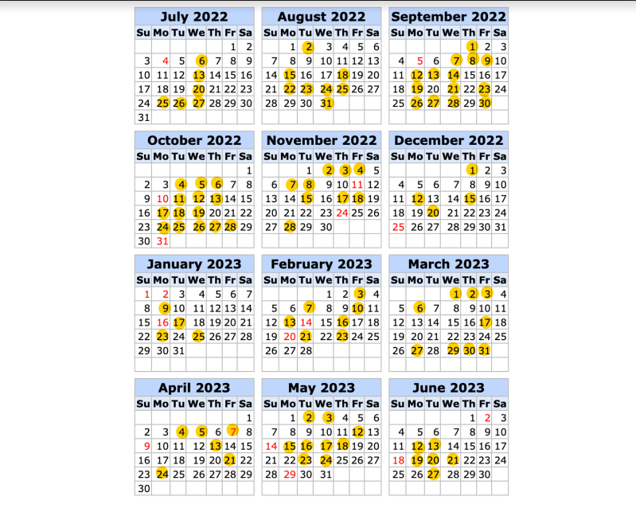

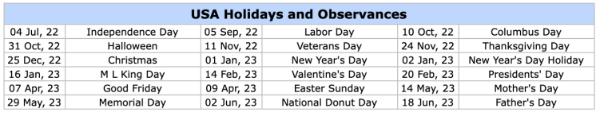

**Appendix D: Conditions of Authorization/Renewal**

NA - No conditions of authorization or renewal are applicable.

1